Kapture - MDM (Master Data Maintenance) Master Data Unit Test Cases

Contents
1. User System Access 2
2. Country Code 3
3. Manual Language 10
4. Carline 15
5. VIN 29
6. ESI Categories 37
7. Other Master Data Screens 43
7.1 Manual Type 43
7.2 Engine Book 45
7.3 Engine Type 47
7.4 Transmission Book 49
7.5 Transmission Type 51
7.6 Drive Axle Type 53
7.7 Body Type 55
7.8 MNAO Model Year Code Mapping 57
7.9 Master Data Locale Mapping 59

Kapture - MDM (Master Data Maintenance) - Master Data
Unit Test Cases
Application URL: https://na.dev.mgss.oc.mazda.com/mdmgt
Application: mdmgt.war (/mdmgt) | Version: v2 | Date: 16-Oct-2026
- Unit Test Case Summary:
# | Test Cases Processes | No. of Test Cases | No. of Success | No. of Failure | Status
1 | User System Access | 1 | 1 | 0 | Pass
2 | Country Code | 5 | 5 | 0 | Pass
3 | Manual Language | 3 | 3 | 0 | Pass
4 | Carline | 11 | 11 | 0 | Pass
5 | VIN | 6 | 6 | 0 | Pass
6 | ESI Categories | 4 | 4 | 0 | Pass
7 | Other Master Data Screens | 9 | 9 | 0 | Pass
 | Total | 39 | 39 | 0 | Pass

User System Access
- User should be able to open MDM and view the Master Data tab on My Page.
Steps:
1. Log in to MGSS with a valid user.
2. Open the URL: https://na.dev.mgss.oc.mazda.com/mdmgt
Expected Result:
- My Page is displayed with the welcome line and the user name / role in the top bar.
- The Master Data tab lists the tiles Country Code, Manual Language, Manual Type, Carline, VIN, ESI Categories, CVC Categories, Display Order, Engine, Transmission, Vehicle Type, MNAO Model Year Code Mapping and Master Data Locale Mapping.
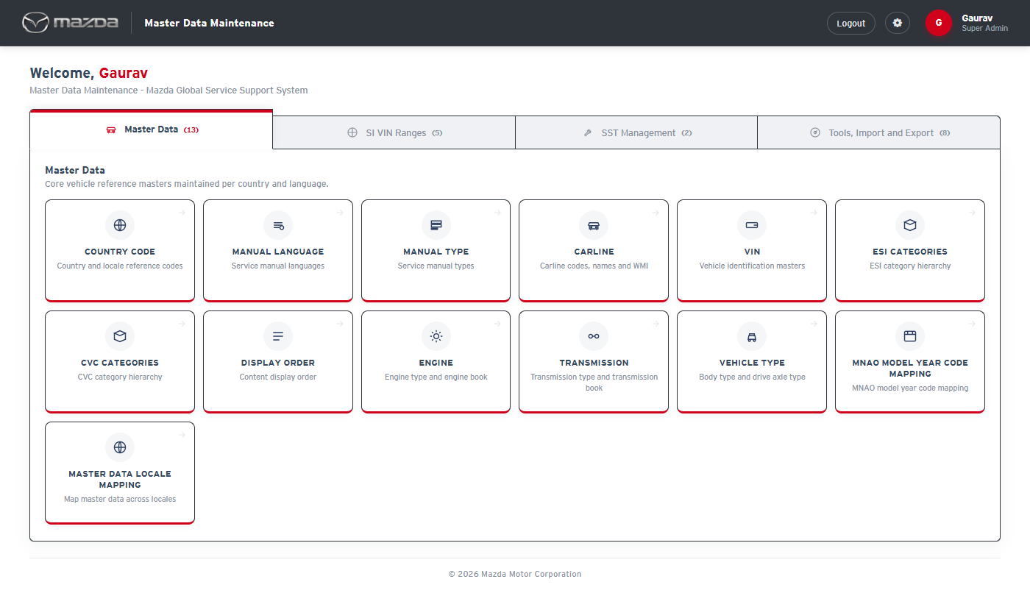
My Page - Master Data tab
Status: Pass
Remarks:

Country Code
- System should not save a Country Code without the mandatory fields.
Steps:
1. Open Country Code.
2. Click Save with Country Code empty.
Expected Result: "Please fill all the fields marked as mandatory (*)." is shown and nothing is saved.
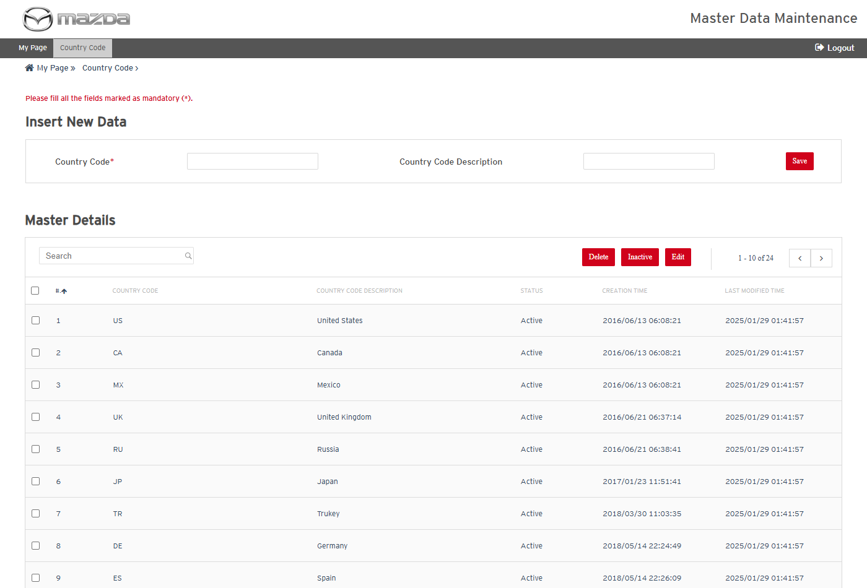
Mandatory field message
Status: Pass
Remarks:

- User should be able to add a new Country Code.
Steps:
1. Enter Country Code ZZ and Description UTC Test Country.
2. Click Save.
Expected Result: "Country Code details saved successfully." is shown and ZZ is listed in Master Details with Status Draft.
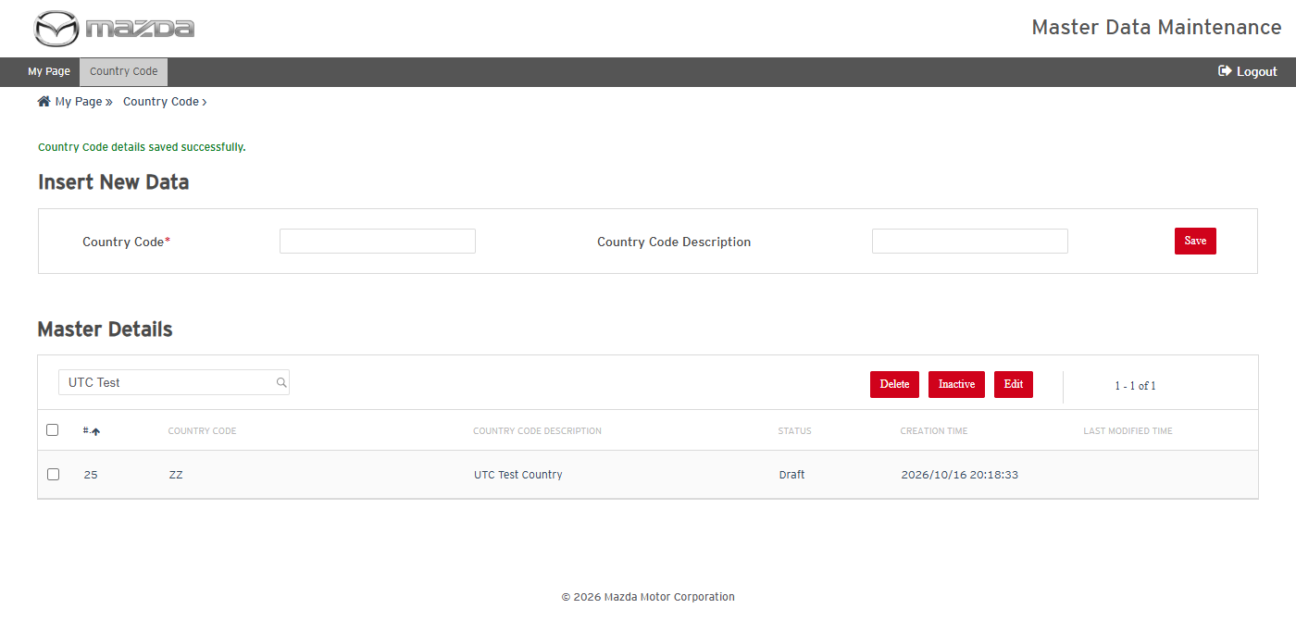
Country Code saved
Status: Pass
Remarks:

- User should be able to edit a Country Code.
Steps:
1. Select the ZZ row and click Edit.
2. Change the description to UTC Test Country Updated and click Save.
Expected Result:
- The selected row becomes editable with Cancel / Save buttons.
- "Country Code details updated successfully for Row No. (n)." is shown and the new description is listed.
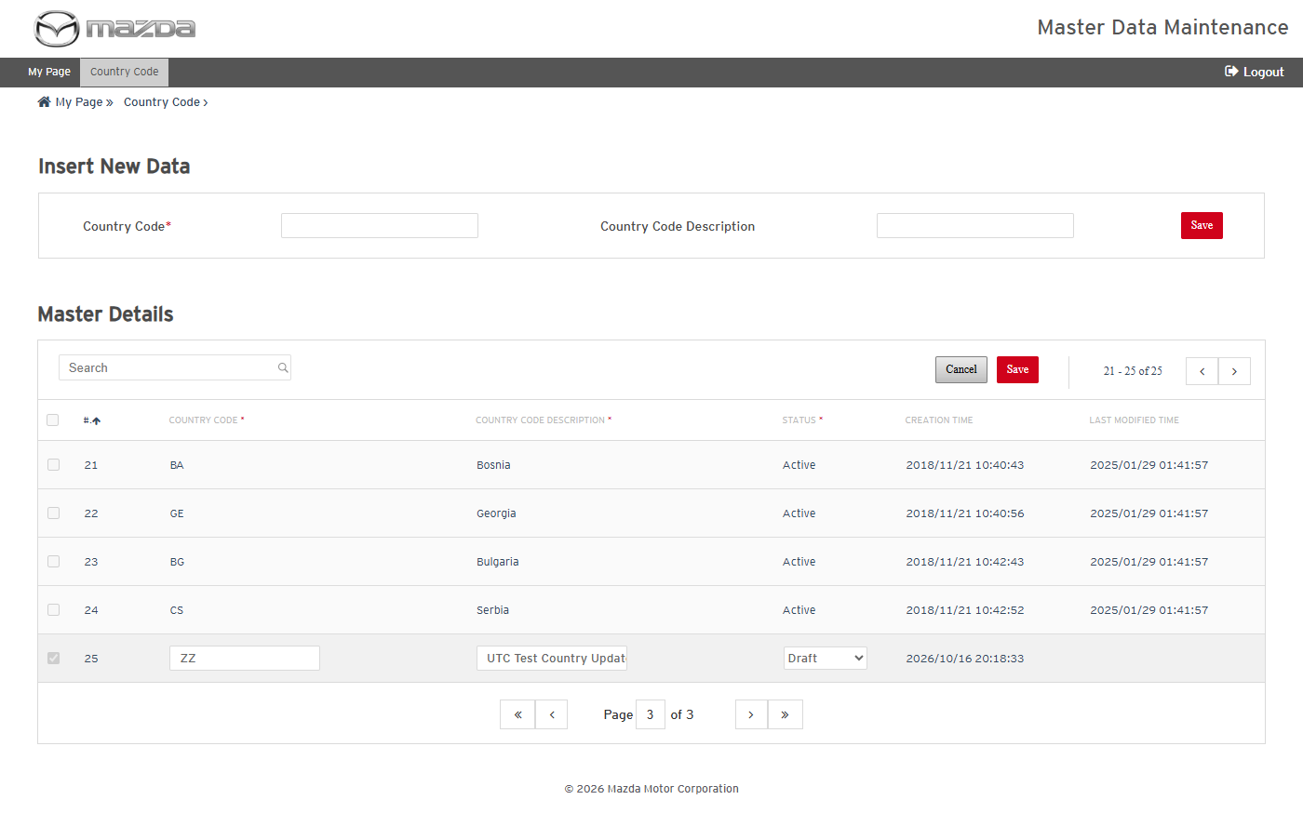
Row in edit mode
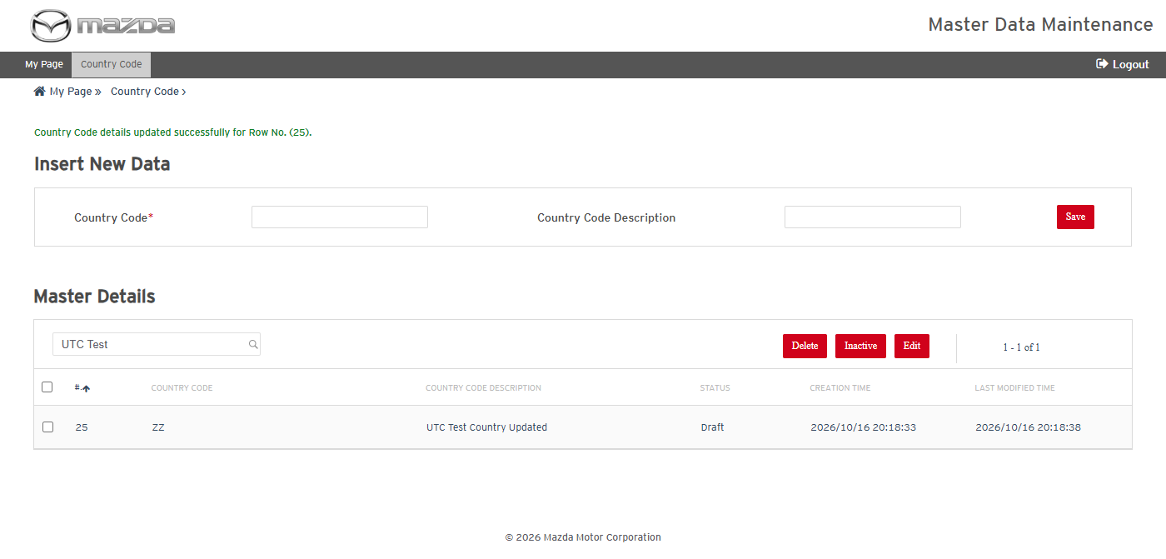
Country Code updated
Status: Pass
Remarks:

- User should be able to inactivate a Country Code.
Steps:
1. Select the ZZ row, click Inactive and confirm with Yes.
Expected Result:
- "Are you sure, you wish to Inactive the Selected Record(s) ?" is asked.
- "Country Code changed to Inactive successfully." is shown and the Status becomes Inactive.
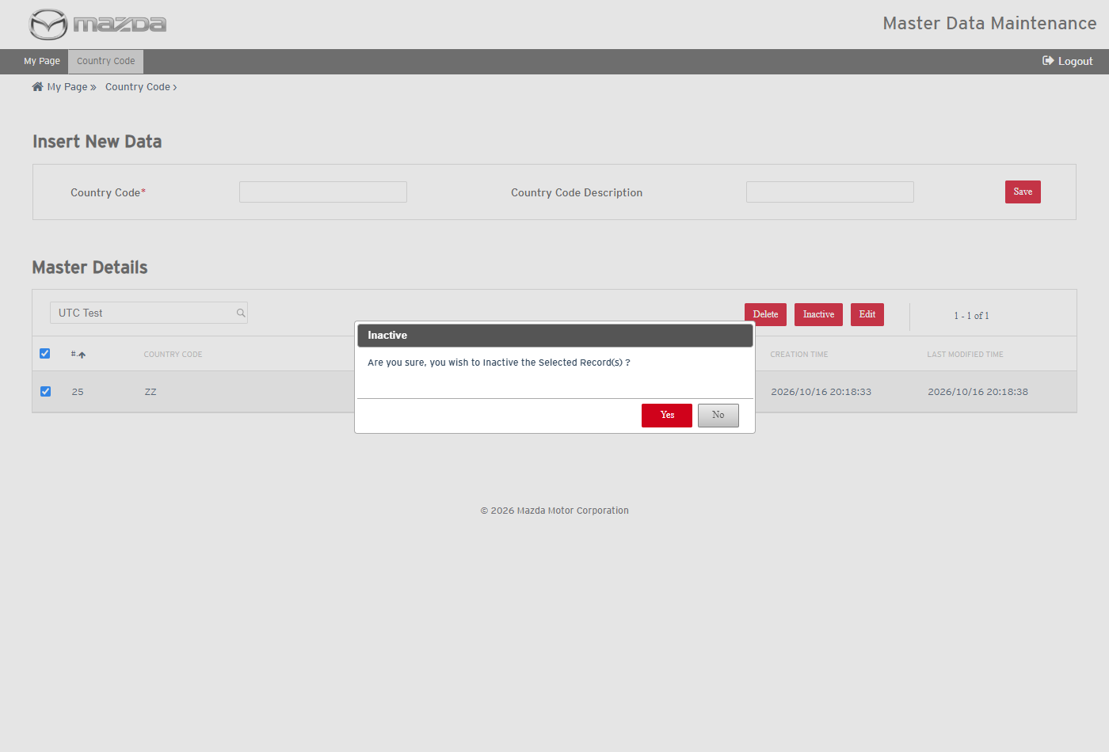
Inactive confirmation
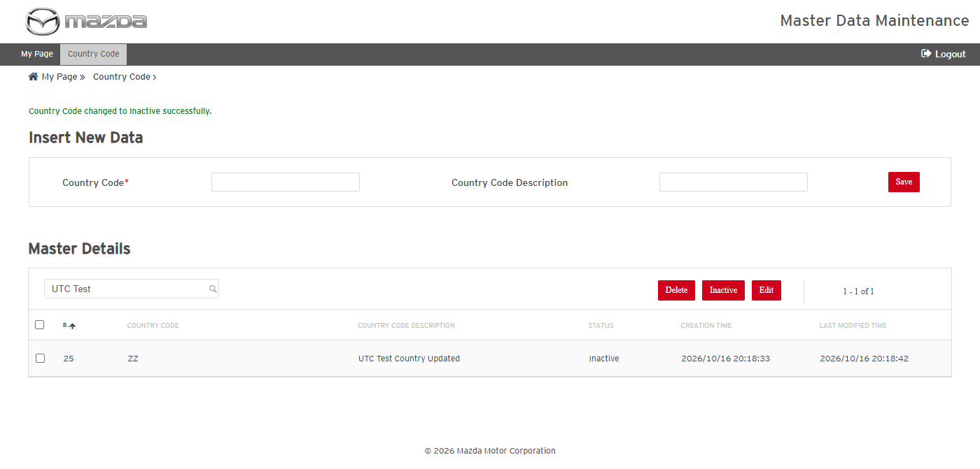
Country Code inactivated
Status: Pass
Remarks:

- User should be able to permanently delete a Country Code.
Steps:
1. Select the ZZ row, click Delete and confirm with Yes.
Expected Result:
- "This action will permanently delete the record and its complete hierarchy from database. Are you sure, you wish to Delete the Selected Record(s) ?" is asked.
- "Country Code Deleted successfully." is shown and ZZ is no longer listed.
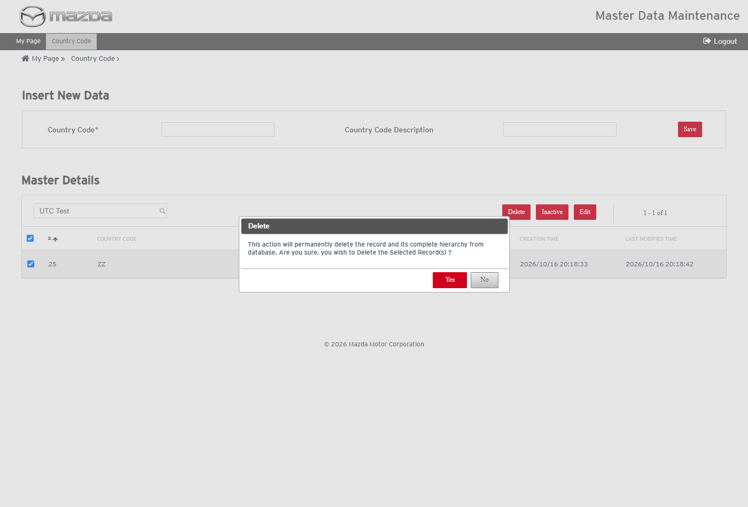
Delete confirmation
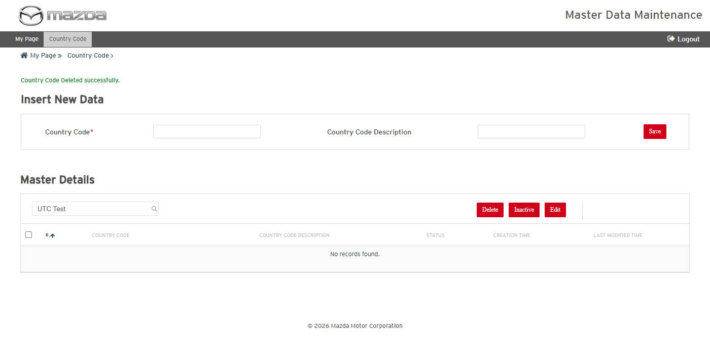
Country Code deleted
Status: Pass
Remarks:

Manual Language
- User should be able to add a Manual Language for a country.
Steps:
1. Open Manual Language and select Country Code Japan.
2. Enter Language Code zz-JP and Description UTC Test Language; click Save.
Expected Result: "Manual Language details saved successfully." is shown and zz-JP is listed under Japan with Status Draft.
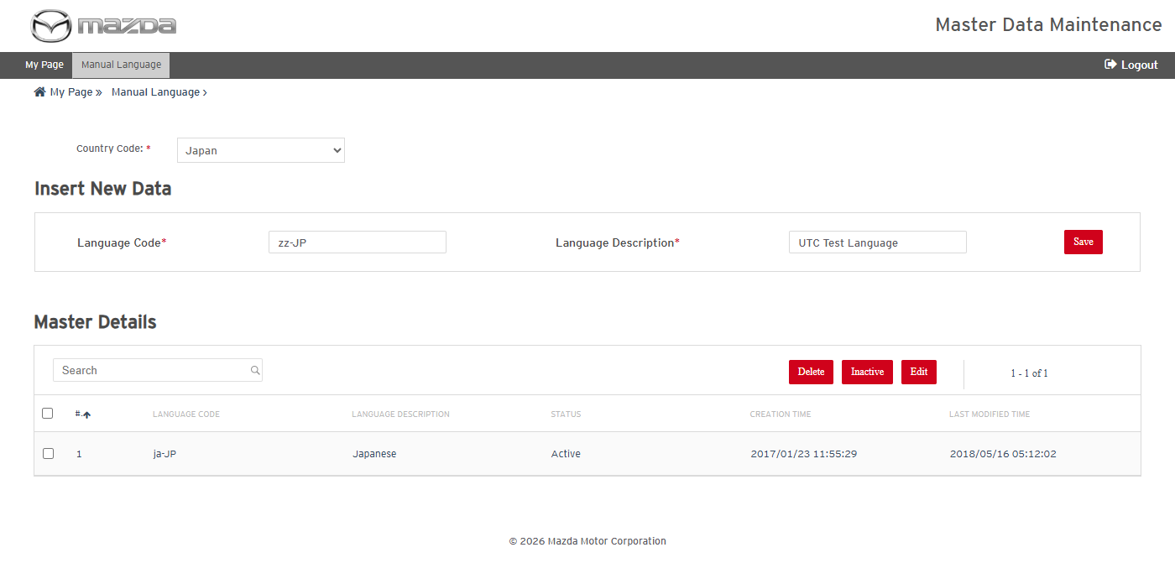
Language entered
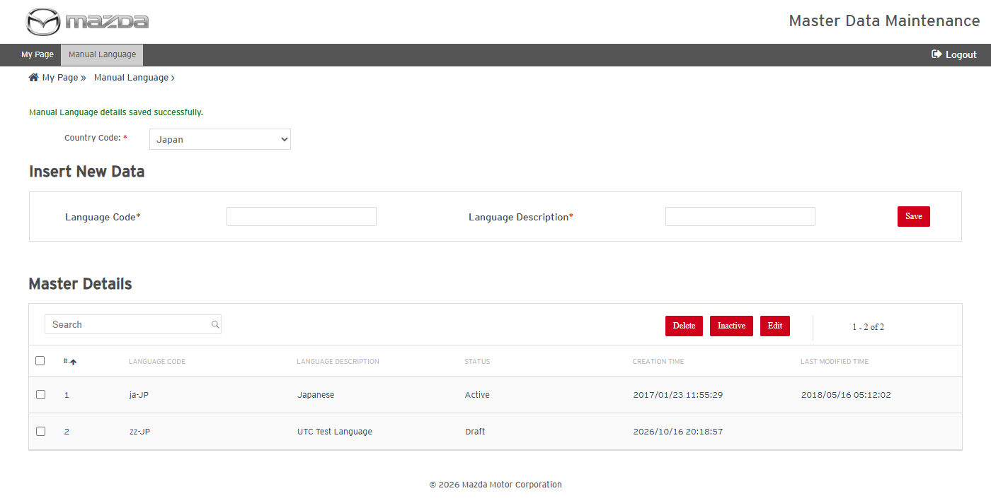
Manual Language saved
Status: Pass
Remarks:

- User should be able to edit a Manual Language.
Steps:
1. Select the zz-JP row, click Edit, change the description and click Save.
Expected Result: "Manual Language details updated successfully for Row No. (n)." is shown and the new description is listed.
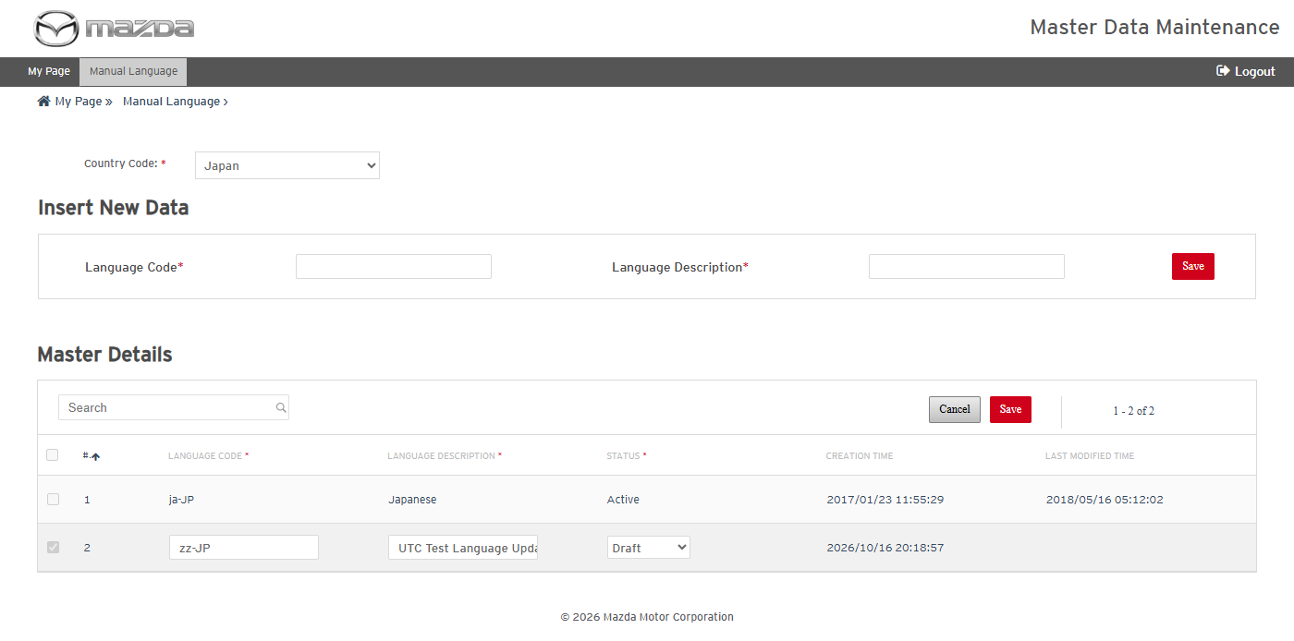
Row in edit mode
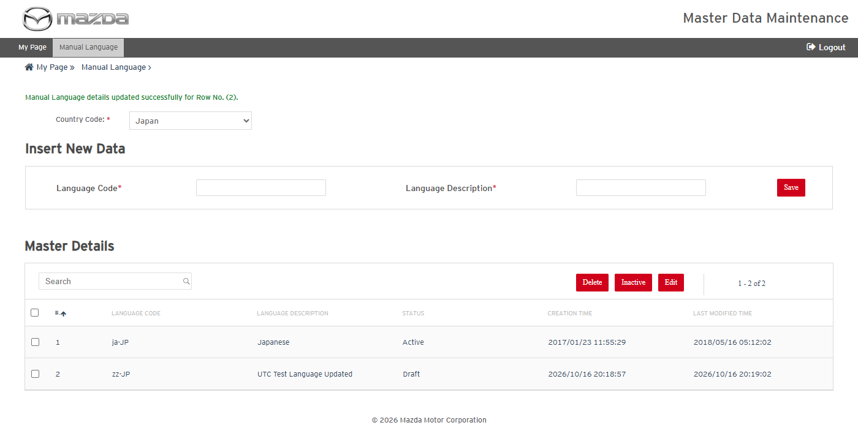
Manual Language updated
Status: Pass
Remarks:

- User should be able to inactivate and permanently delete a Manual Language.
Steps:
1. Select the zz-JP row, click Inactive and confirm with Yes.
2. Select it again, click Delete and confirm with Yes.
Expected Result:
- "Manual Language changed to Inactive successfully." is shown and the Status becomes Inactive.
- "Manual Language Deleted successfully." is shown and zz-JP is no longer listed.
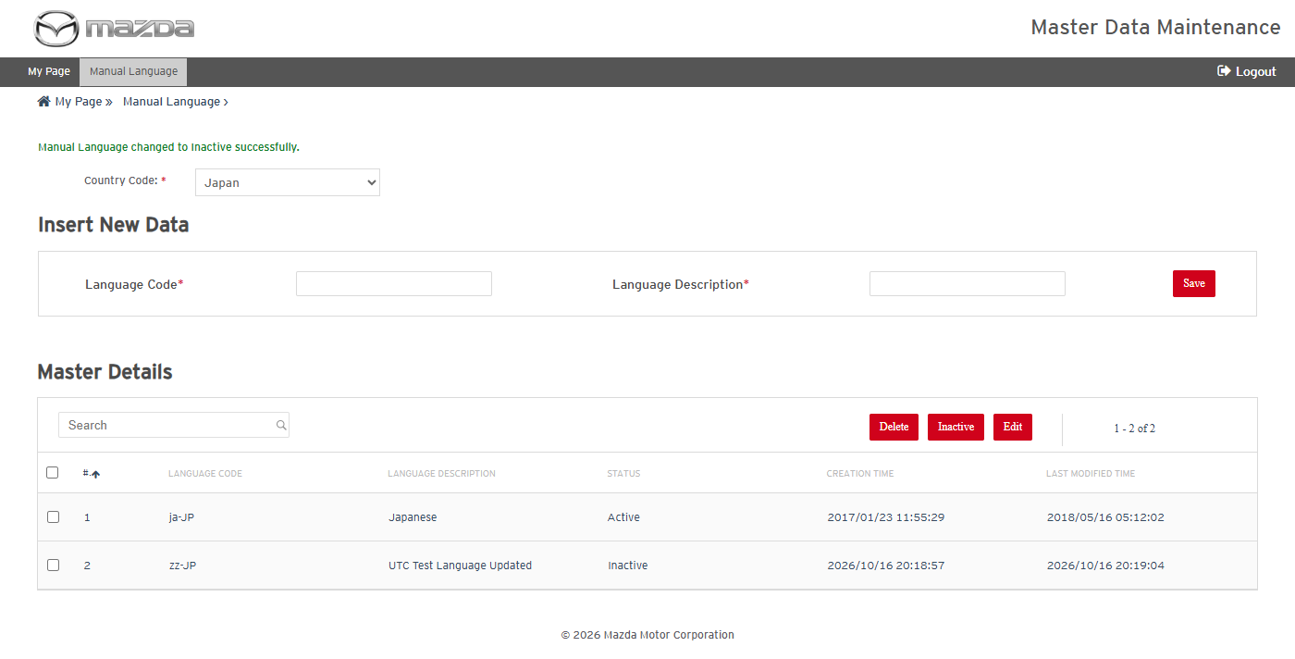
Manual Language inactivated
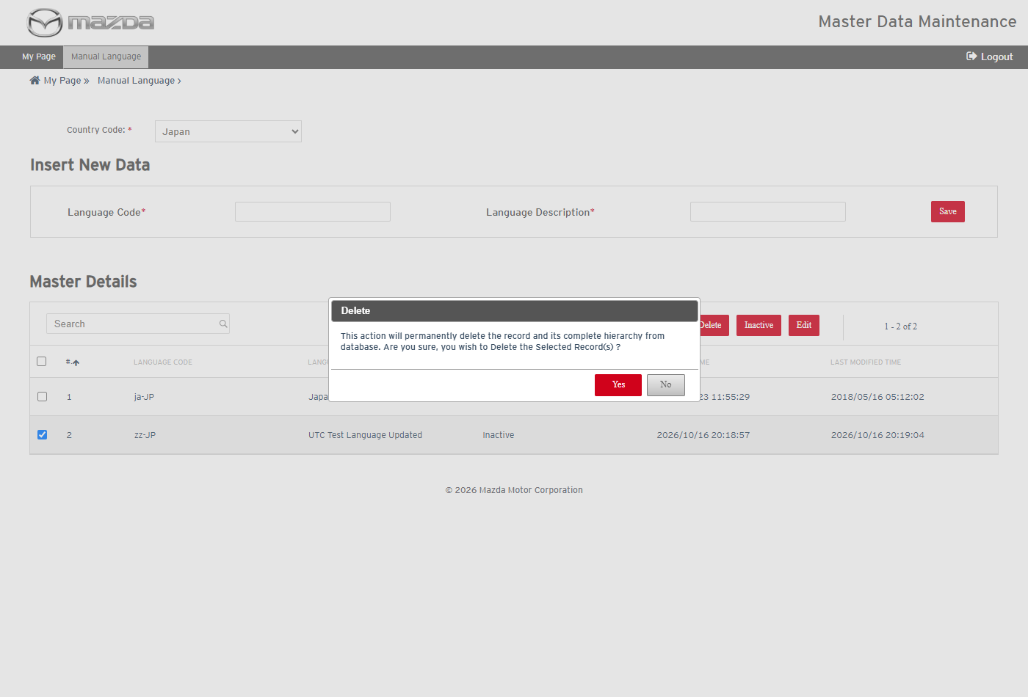
Delete confirmation
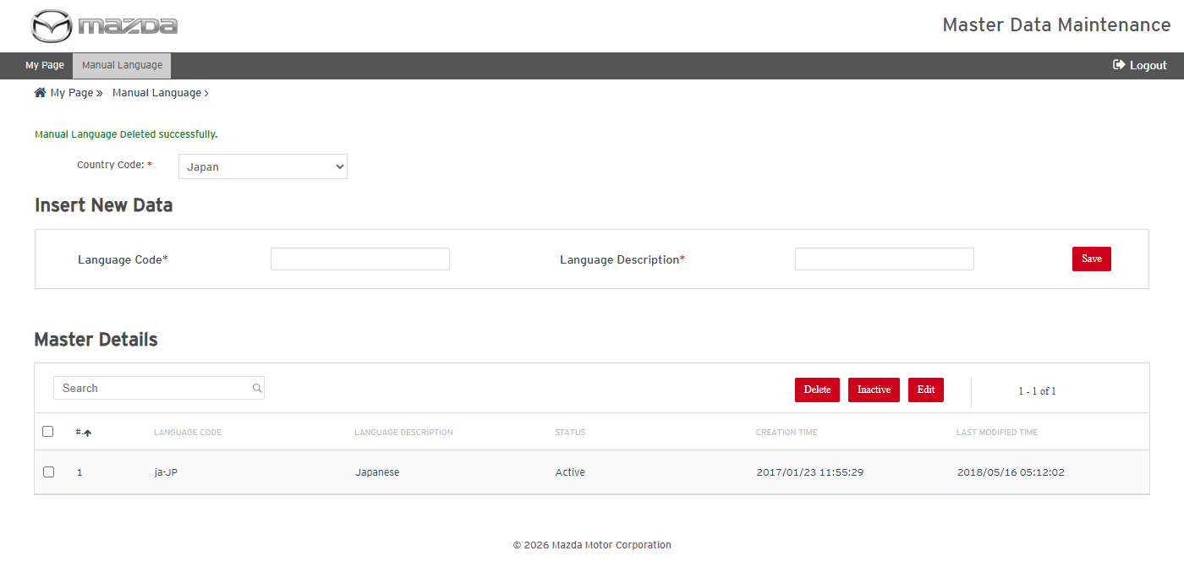
Manual Language deleted
Status: Pass
Remarks:

Carline
Carline cases are executed with Country Code Japan / Language Japanese. The import cases use the screen's Download Template; its last column ACTION takes A (Add), U (Update), D (Delete) or blank - A, U and blank all mean "update if the record exists, else add"; only D deletes. An inactivated record is no longer listed on the screen.
- User should be able to view and search Carlines.
Steps:
1. Open Carline, select Country Code Japan / Language Japanese and click View.
2. Select Model Type New in Search Master Details and click Search.
Expected Result: The Carlines matching the criteria are listed with paging (Carline Code, names, WMI Code, Model Type, ESI Category Flag, IC Display Code, Status).
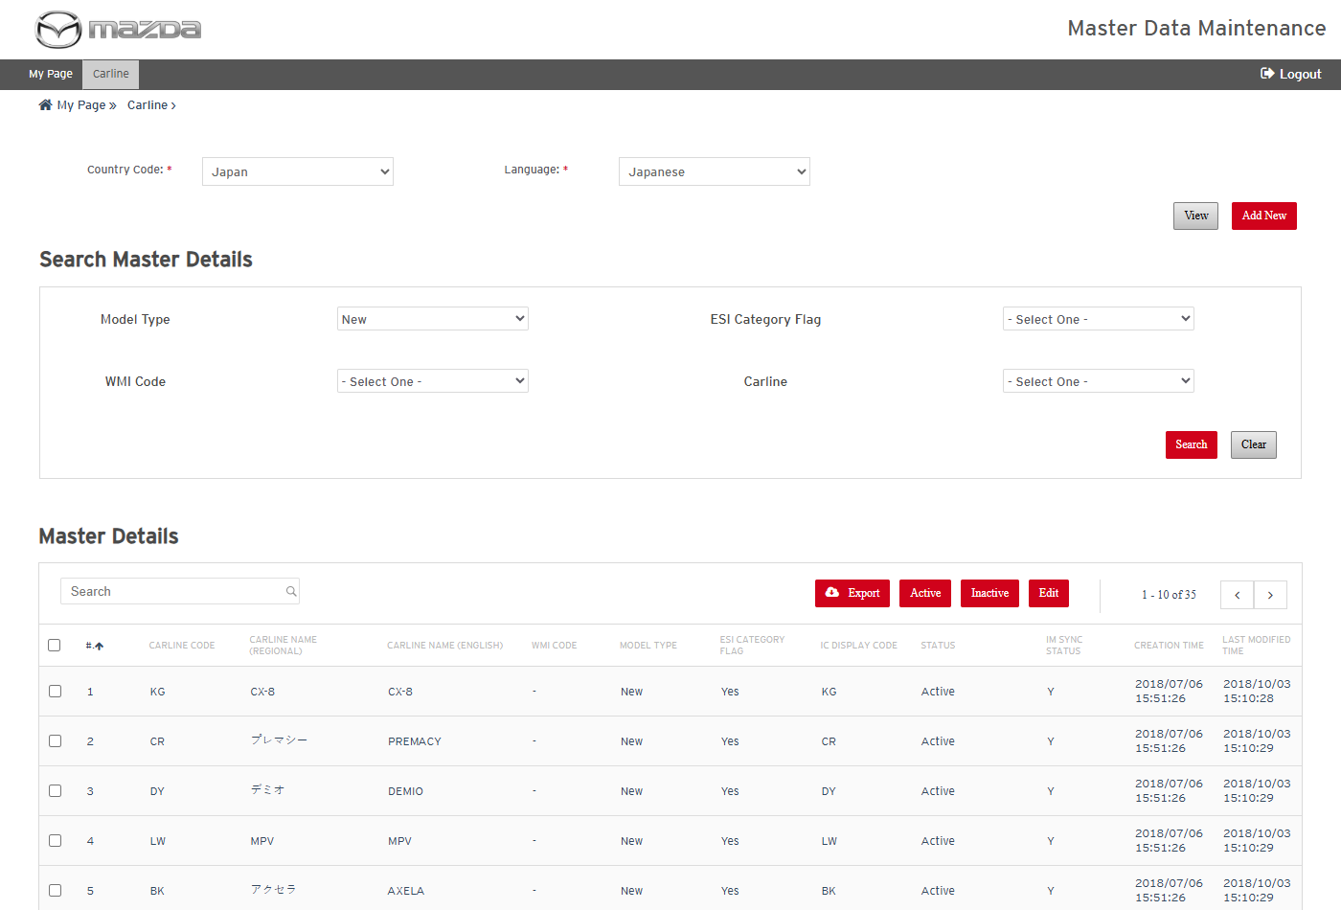
Carline search result
Status: Pass
Remarks:

- User should be able to add a new Carline.
Steps:
1. Click Add New.
2. Select Model Type New, ESI Category Flag No, WMI Code - and Carline ADDNEW; enter the Carline names UTC TEST CARLINE, Carline Code UTC1 and IC Display Code UTC1.
3. Click Save.
Expected Result: "Carline details saved successfully." is shown and UTC1 is listed with Status Draft.
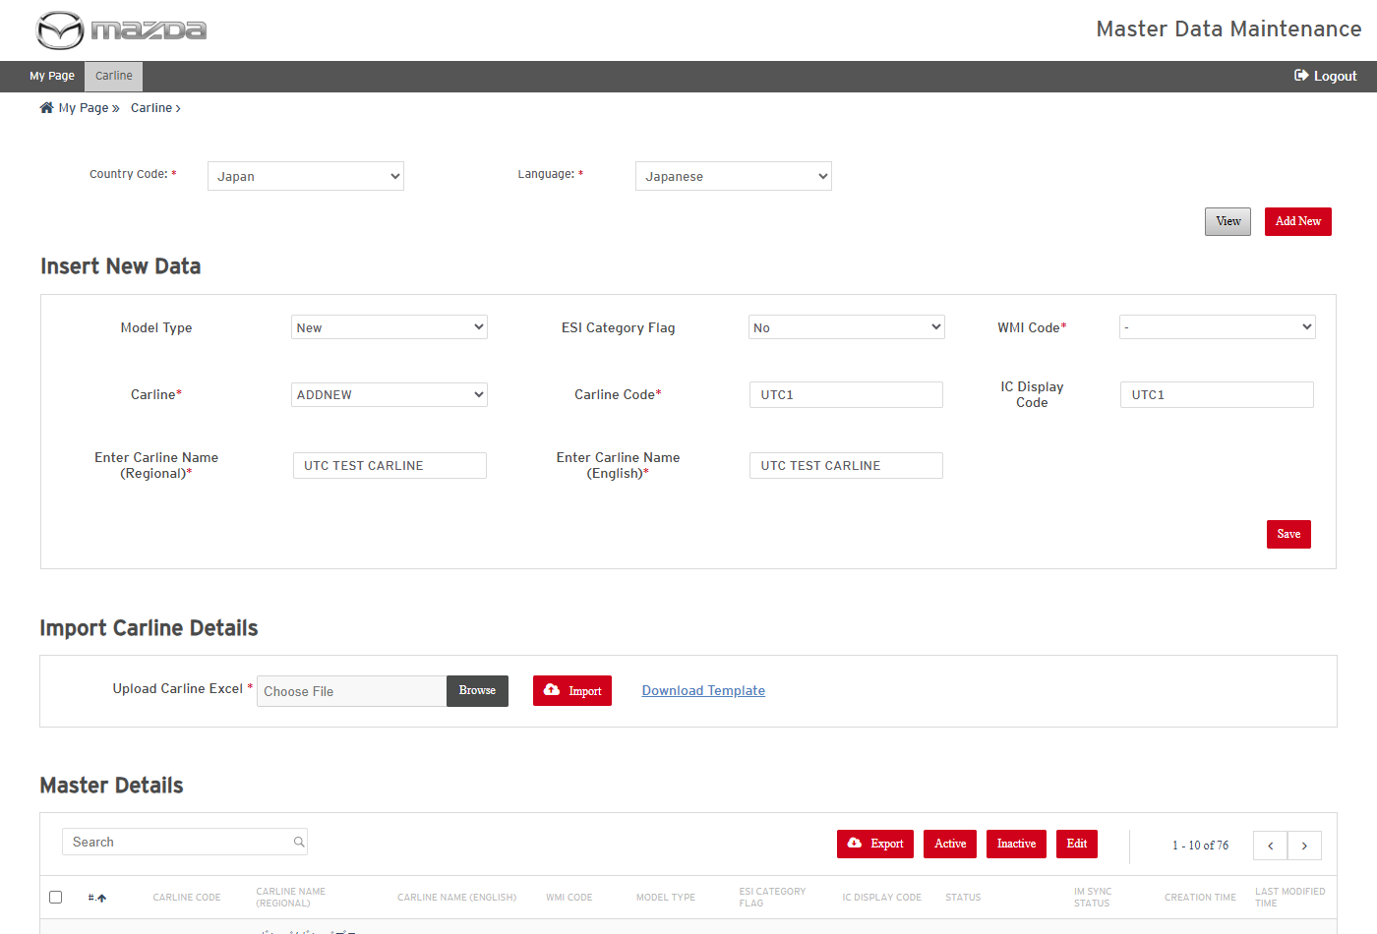
Add New Carline form
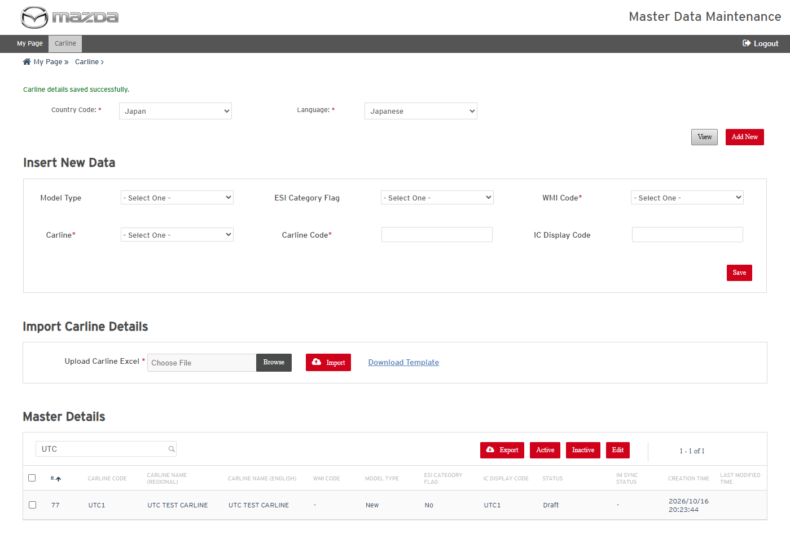
Carline saved
Status: Pass
Remarks:

- User should be able to edit a Carline.
Steps:
1. Select the UTC1 row and click Edit.
2. Change IC Display Code to UTC1-IC and click Save.
Expected Result: "Carline details updated successfully for Row No. (n)." is shown and the new IC Display Code is listed.
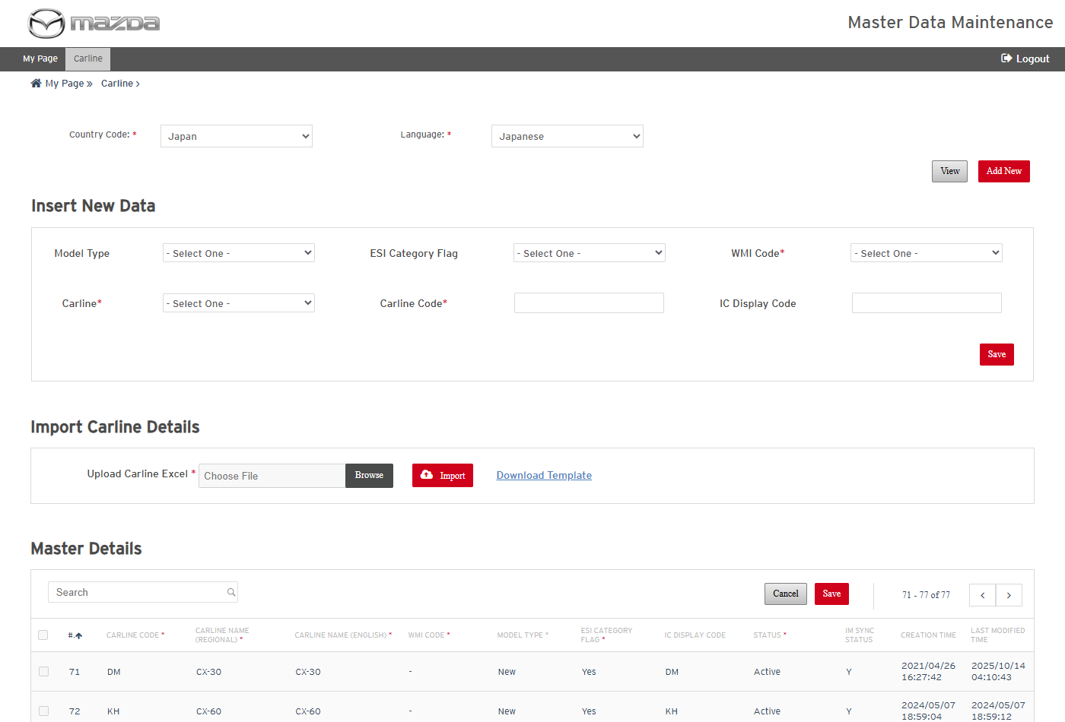
Row in edit mode
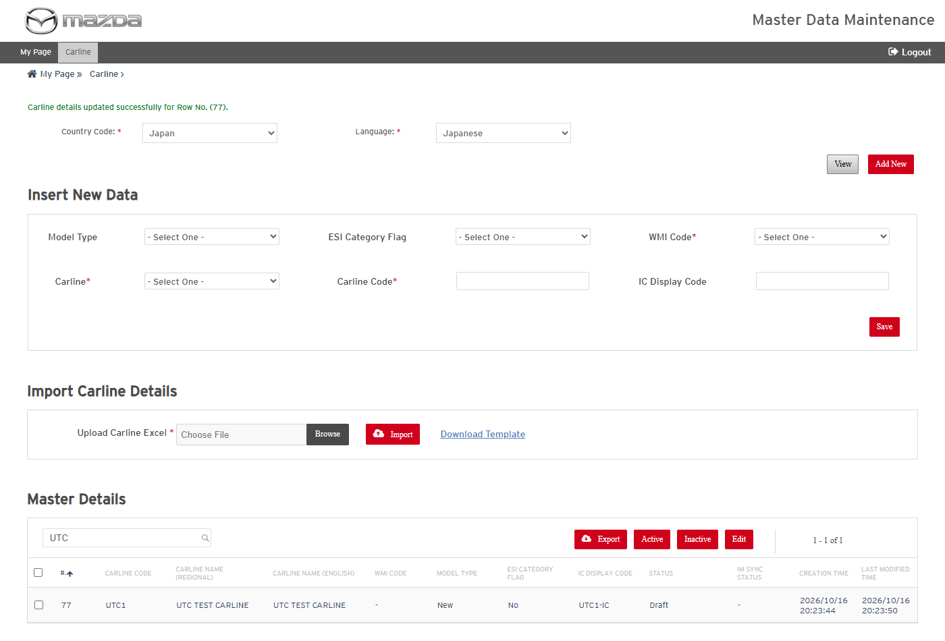
Carline updated
Status: Pass
Remarks:

- User should be able to activate a Draft Carline.
Steps:
1. Select the UTC1 row, click Active and confirm with Yes.
Expected Result:
- "Are you sure, you wish to Active the Selected Record(s) ?" is asked.
- "Carline changed to Active successfully." is shown and the Status becomes Active.
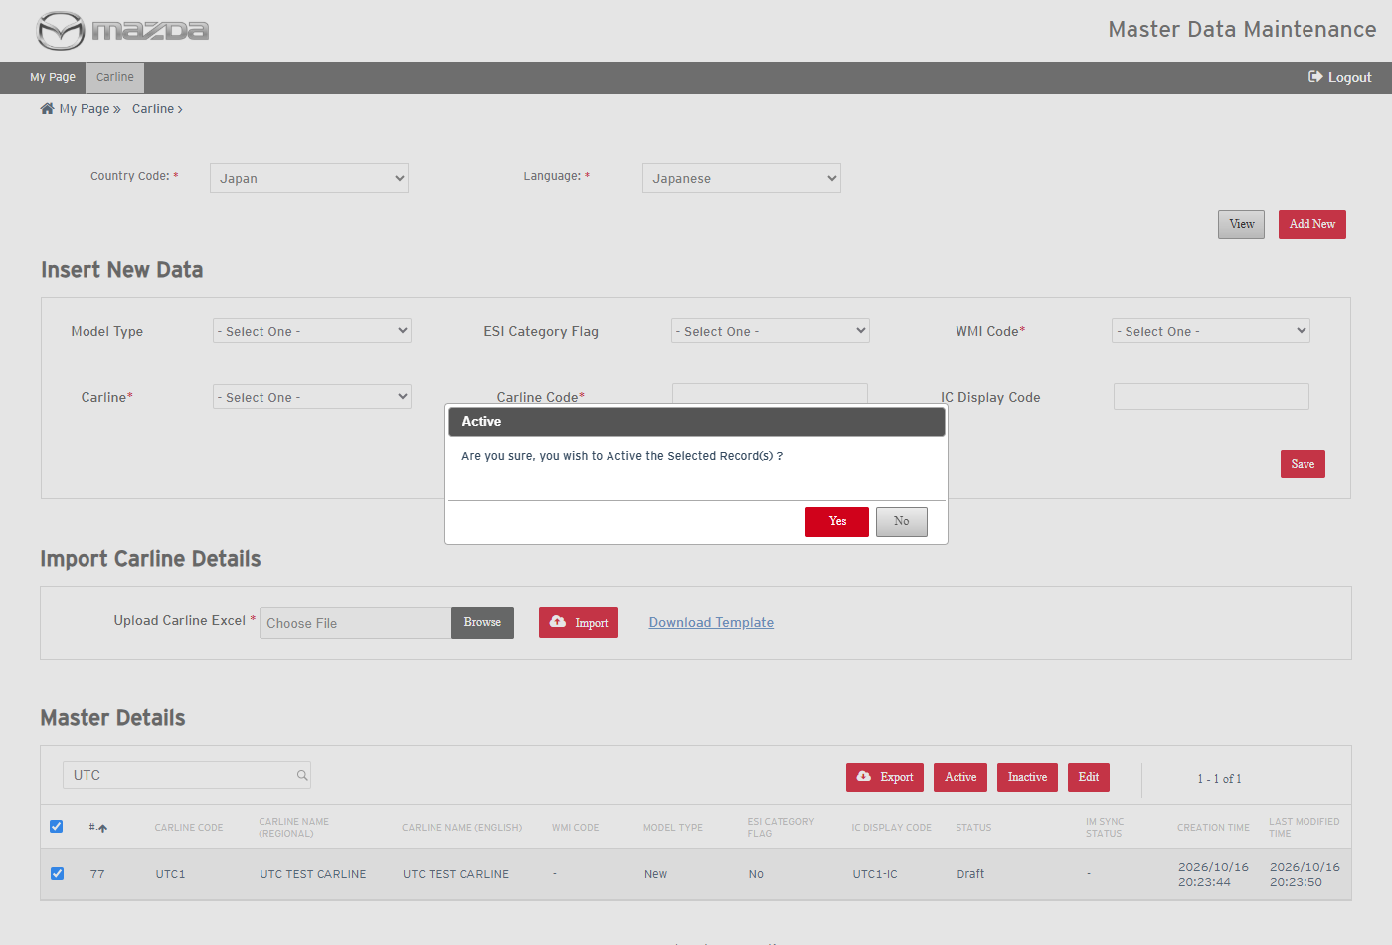
Active confirmation
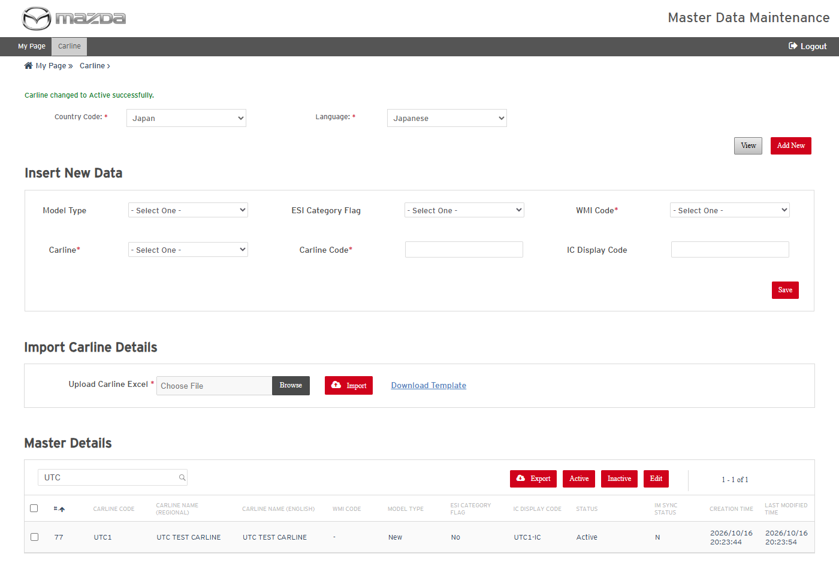
Carline activated
Status: Pass
Remarks:

- User should be able to export the selected Carlines.
Steps:
1. Select the UTC1 row and click Export.
2. Open the downloaded Excel.
Expected Result: The Excel (<Country>_<Language>_CARLINE_<timestamp>) holds the selected Carline with all its columns.
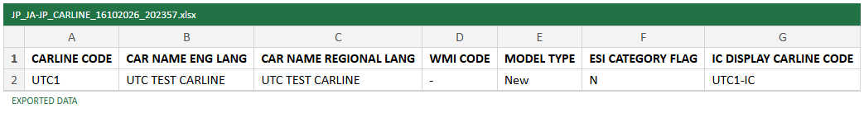
Exported Carline Excel
Status: Pass
Remarks:

- User should be able to inactivate a Carline.
Steps:
1. Select the UTC1 row, click Inactive and confirm with Yes.
Expected Result:
- "Are you sure, you wish to Inactive the Selected Record(s) ?" is asked.
- "Carline changed to Inactive successfully." is shown and UTC1 is no longer listed.
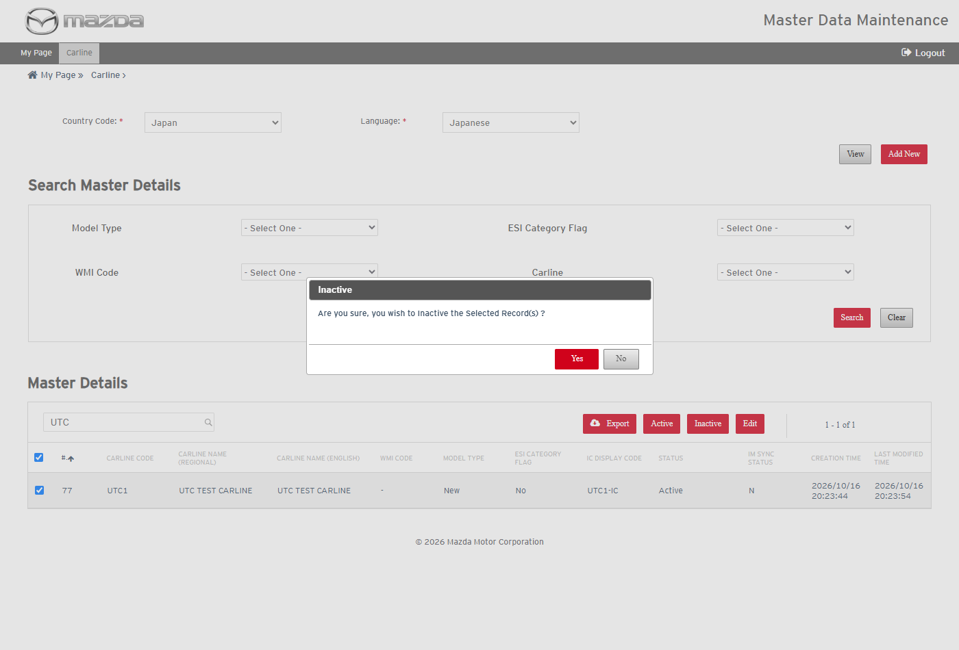
Inactive confirmation
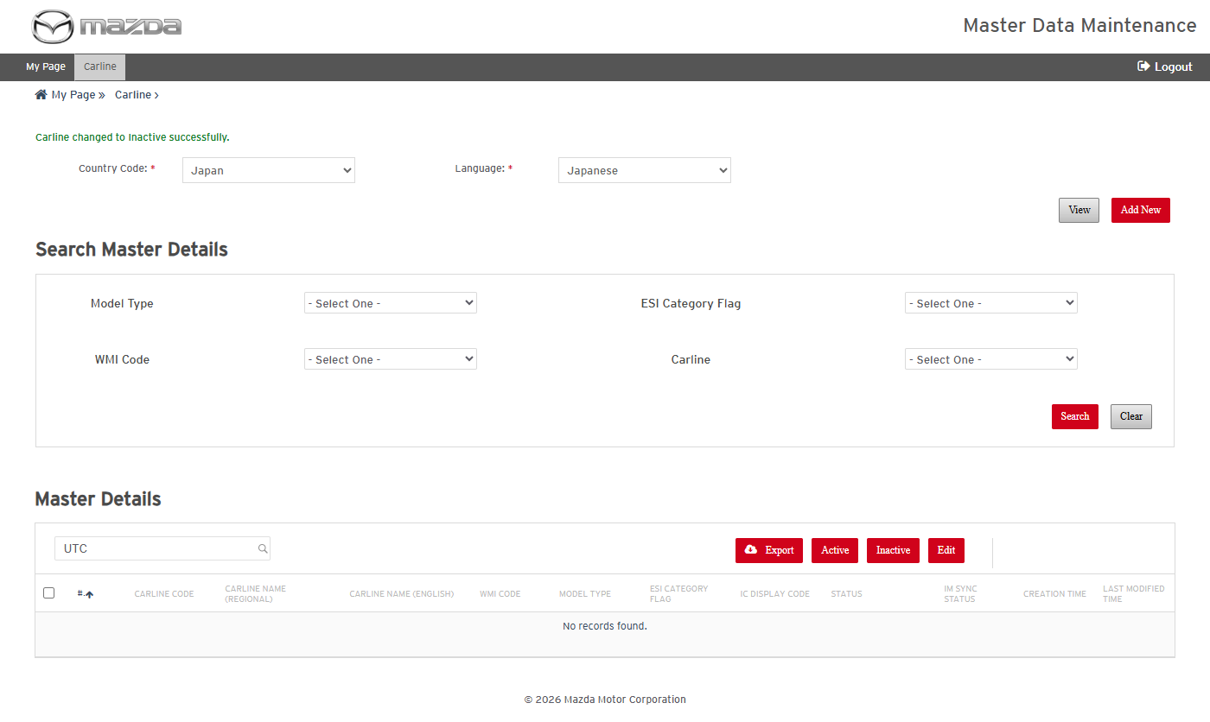
Carline inactivated - no longer listed
Status: Pass
Remarks:

- User should be able to download the Carline import template.
Steps:
1. Click Download Template in Import Carline Details and open the Excel.
Expected Result:
- Sheet CARLINE has the import columns with ACTION as the last column.
- Sheet INSTRUCTIONS describes every column.
Template - CARLINE sheet
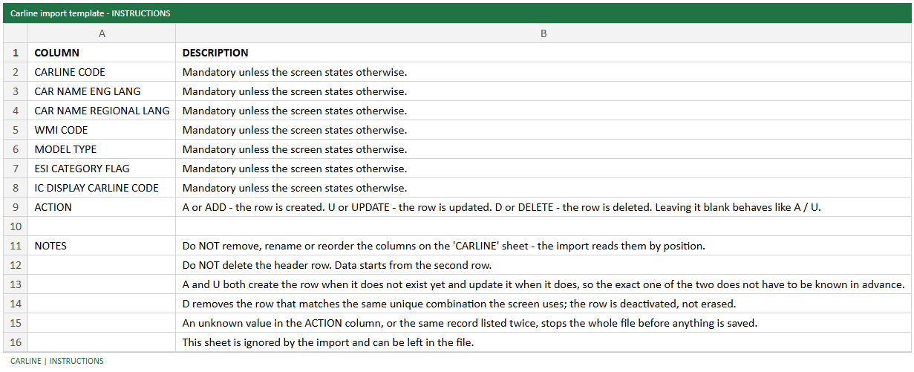
Template - INSTRUCTIONS sheet
Status: Pass
Remarks:

- User should be able to add and update Carlines by import (Action A / U).
Steps:
1. In the template enter UTC2 with Action A and UTC1 (IC Display Code UTC1-U) with Action U.
2. Click Add New, choose the Excel in Upload Carline Excel and click Import.
Expected Result: "2 rows successfully imported." is shown and both Carlines are listed with the imported values.
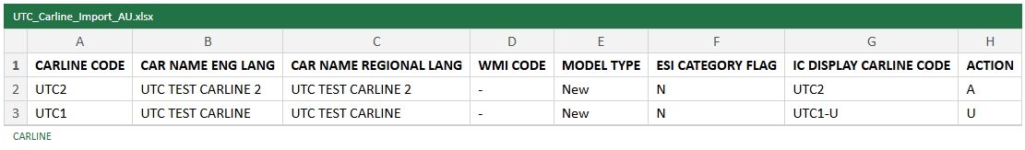
Import file - Action A / U
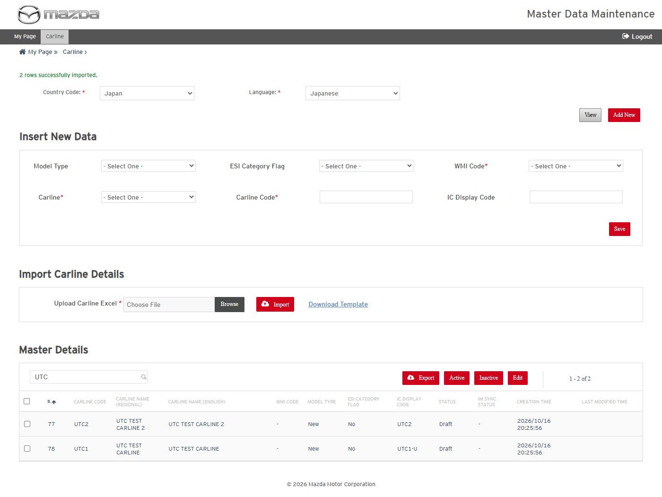
Import result
Status: Pass
Remarks:

- System should reject an import row with an unknown Action value.
Steps:
1. Import a file whose row has Action X.
Expected Result: "Unknown Action value detected at Row No. 2." is shown and nothing is imported.
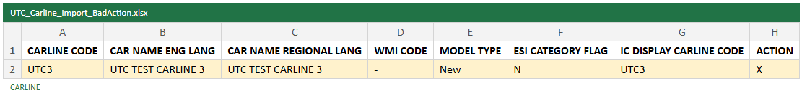
Import file - Action X
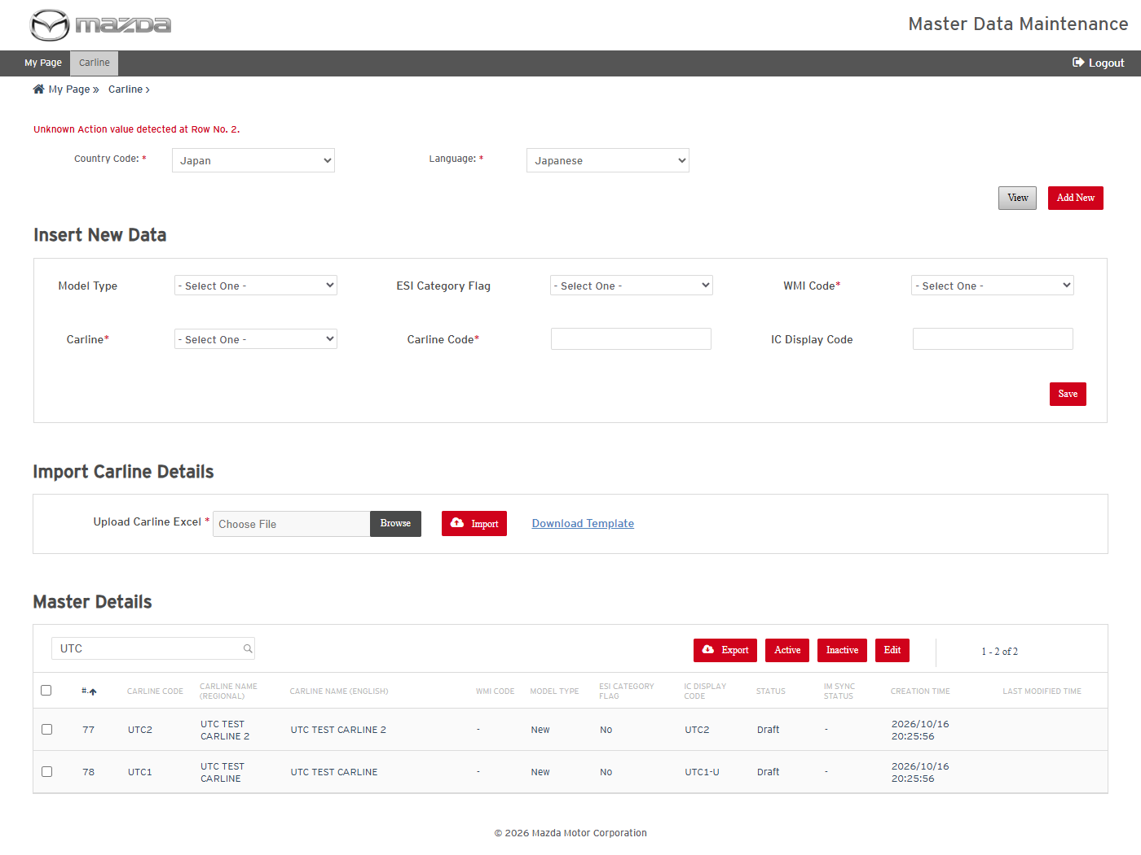
Unknown Action message
Status: Pass
Remarks:

- System should report duplicate rows in an import file.
Steps:
1. Import a file with the same Carline (UTC3) on two rows.
Expected Result:
- "Duplicate Carline data found at Row No. 3 in the uploaded Excel." is shown.
- The first row is imported ("1 rows successfully imported.") and the duplicate row is skipped ("1 duplicate rows found.").
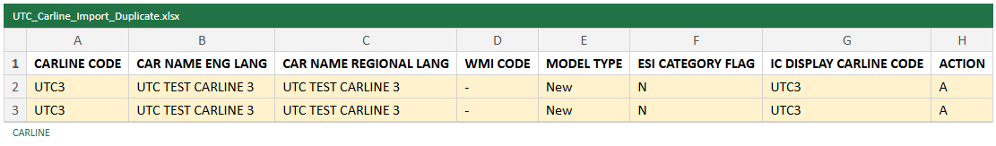
Import file - duplicate rows
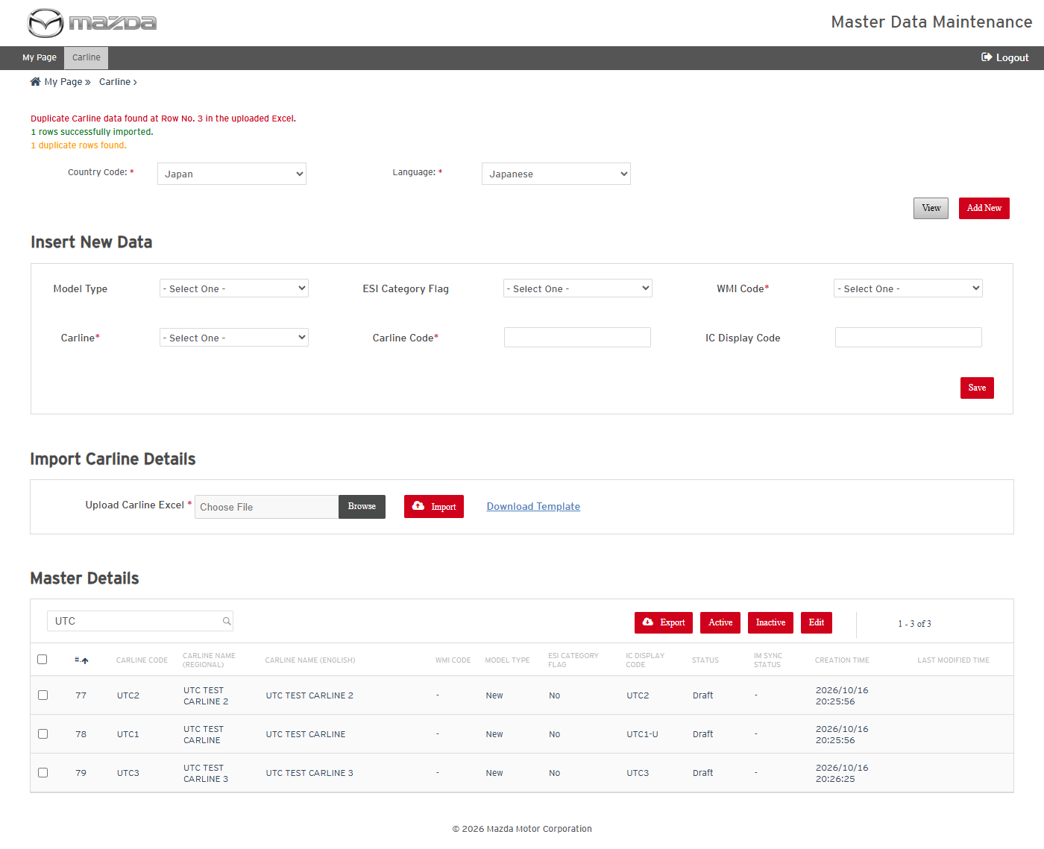
Duplicate rows message
Status: Pass
Remarks:

- User should be able to delete Carlines by import (Action D).
Steps:
1. Import a file with UTC1, UTC2 and UTC3 and Action D on every row.
Expected Result: "3 rows successfully deleted." is shown and the Carlines are no longer listed.
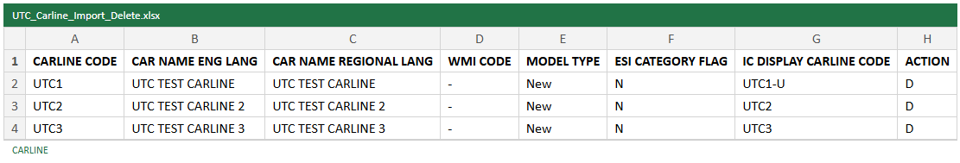
Import file - Action D
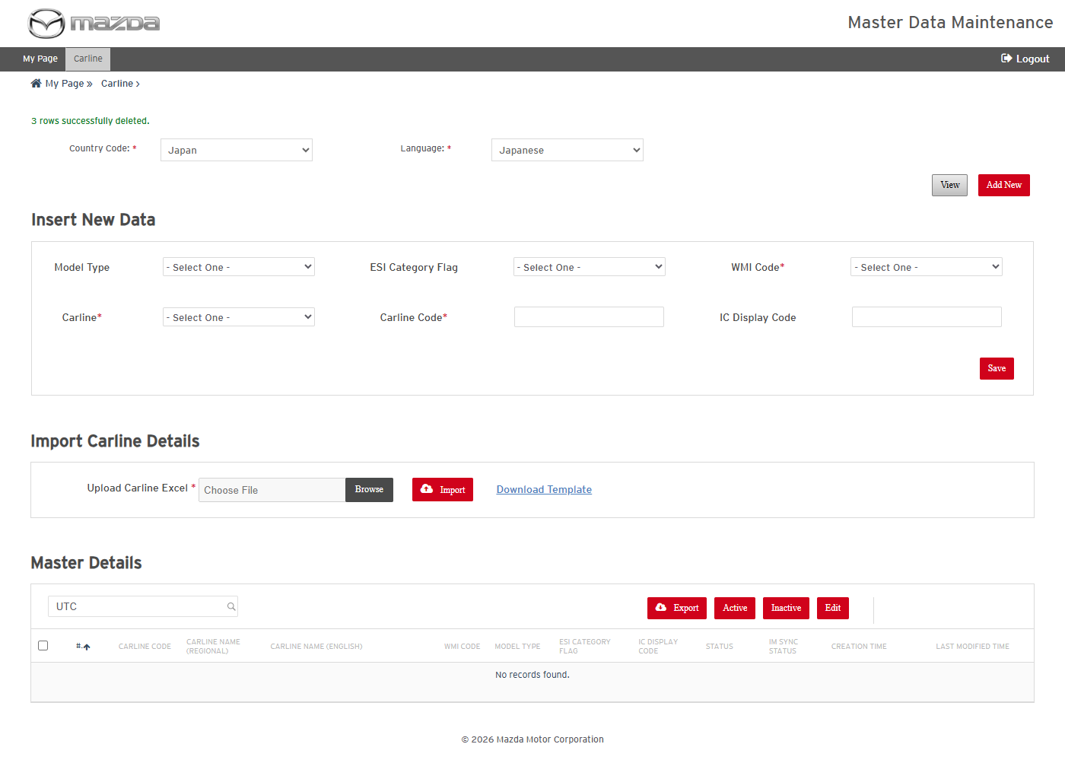
Import result - deleted
Status: Pass
Remarks:

VIN
VIN cases are executed with Country Code Japan / Language Japanese and Model CX-60 (KH).
- User should be able to view the VINs of a model.
Steps:
1. Open VIN, select Country Code Japan / Language Japanese, Model CX-60 (KH) and click View.
Expected Result: The VIN ranges of the model are listed (WMI, Group, VDS, VIS range, Engine and Transmission codes, Status) with the Search Master Details criteria.
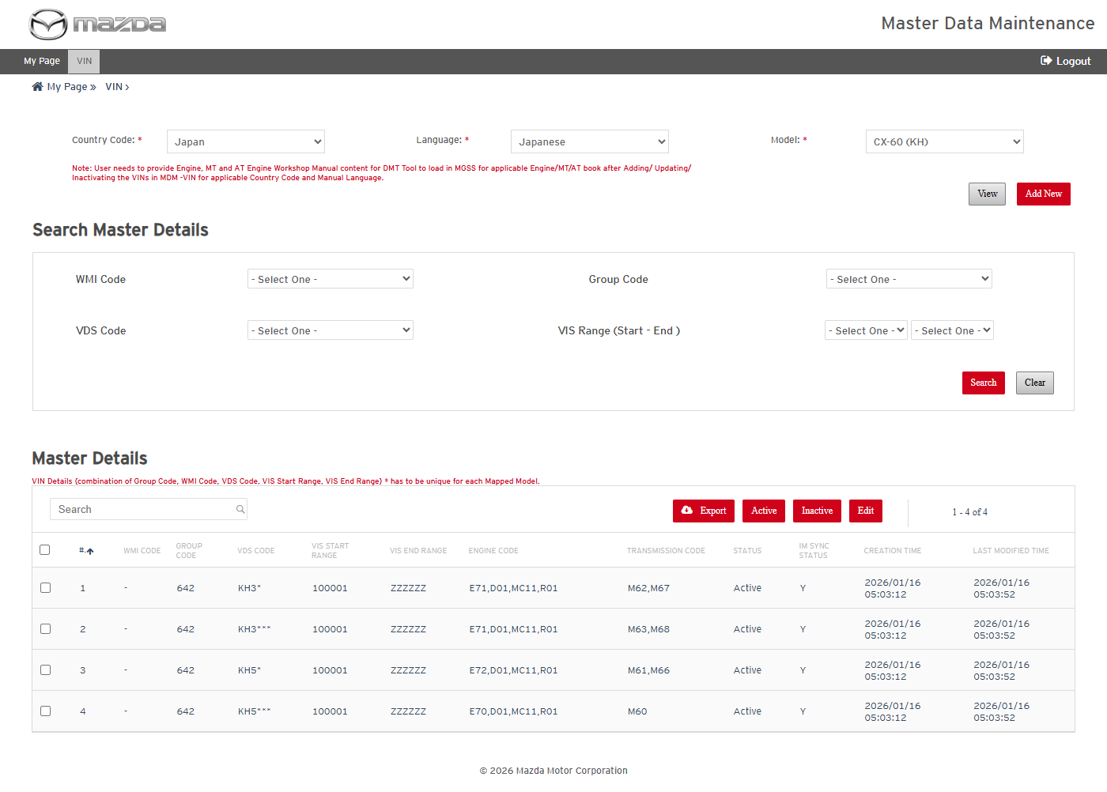
VIN list of CX-60 (KH)
Status: Pass
Remarks:

- User should be able to add a new VIN range.
Steps:
1. Click Add New.
2. Select WMI Code -, Group Code 642, VDS Code ADDNEW (KH9*), VIS Start / End Range ADDNEW (100001 / ZZZZZZ); enter Engine Code E71,D01,MC11,R01 and Transmission Code M62.
3. Click Save.
Expected Result: "VIN details saved successfully." is shown and KH9* is listed with Status Draft.
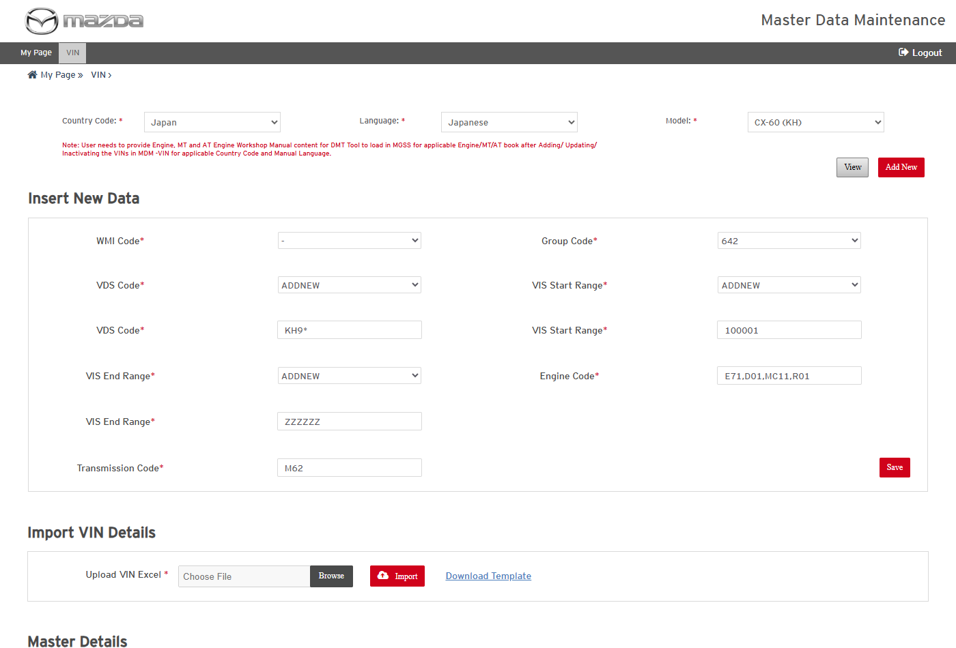
Add New VIN form
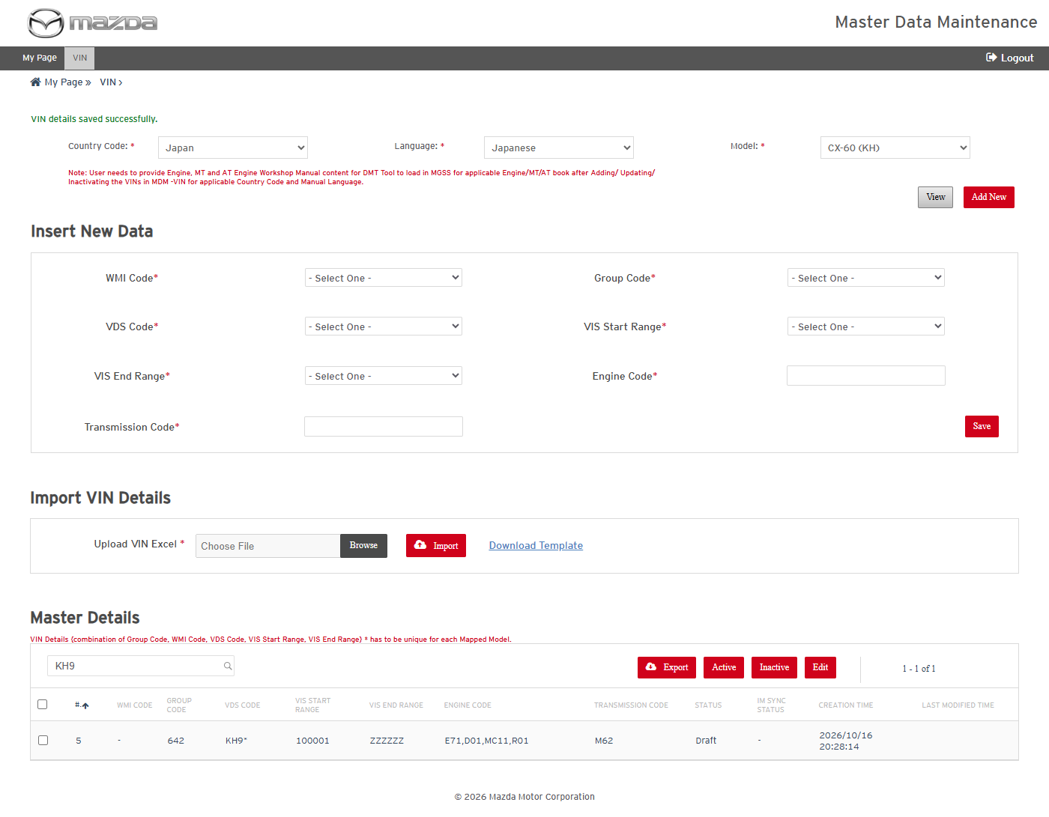
VIN saved
Status: Pass
Remarks:

- User should be able to edit a VIN range.
Steps:
1. Select the KH9* row and click Edit.
2. Change Transmission Code to M62,M67 and click Save.
Expected Result: "VIN details updated successfully for Row No. (n)." is shown and the new Transmission Code is listed.
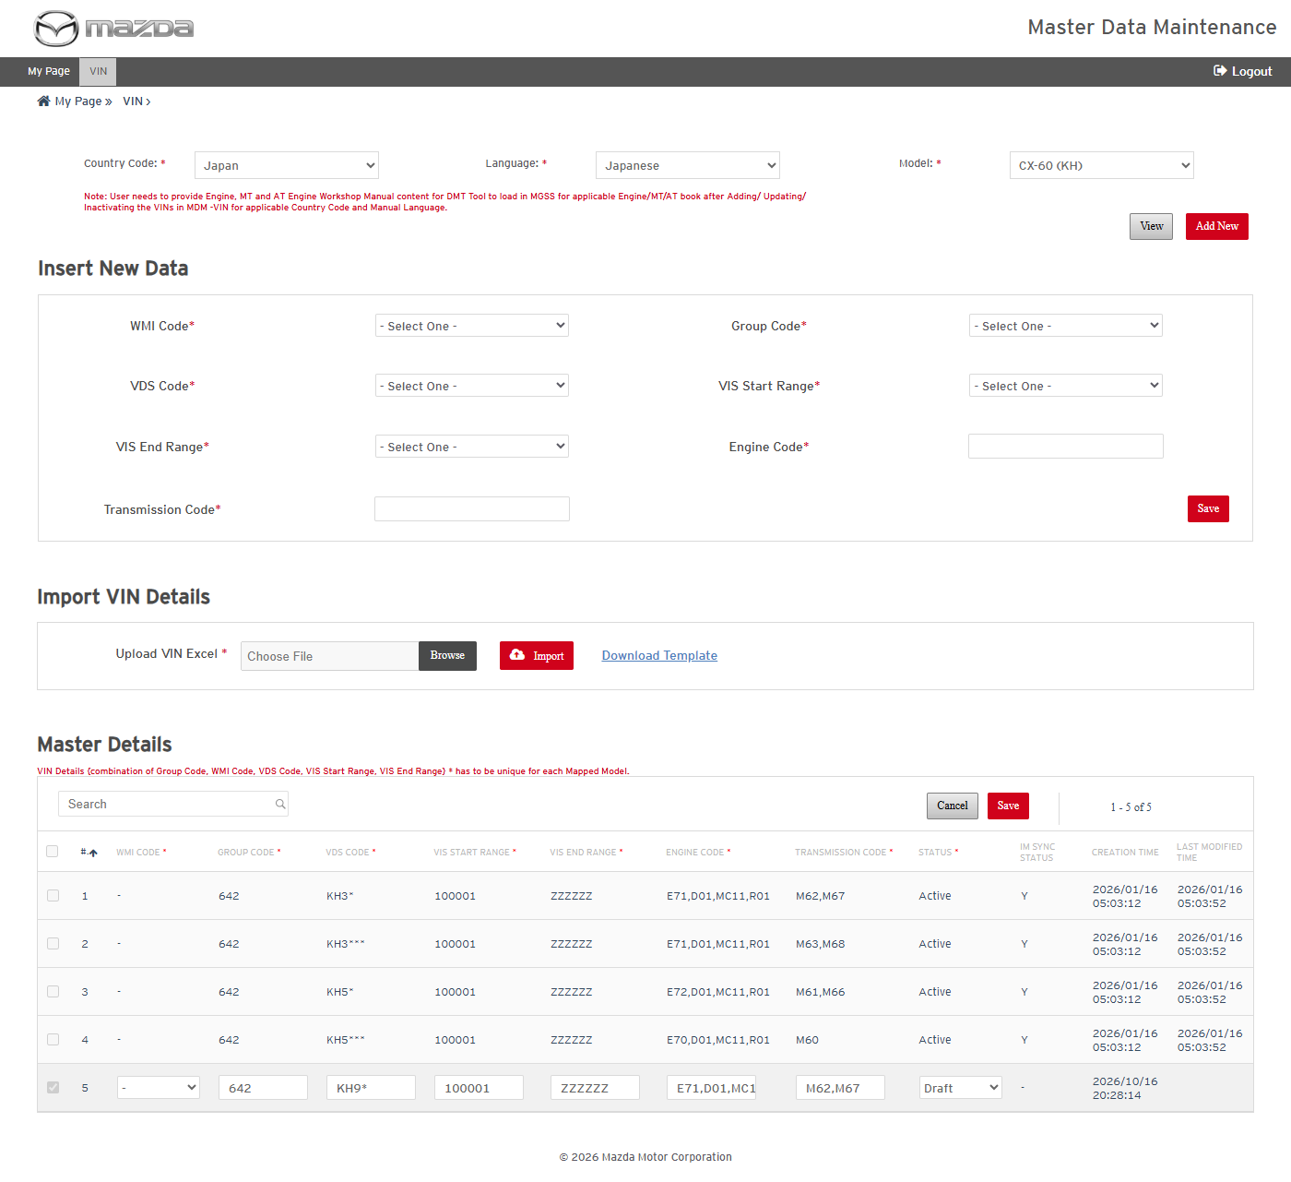
Row in edit mode
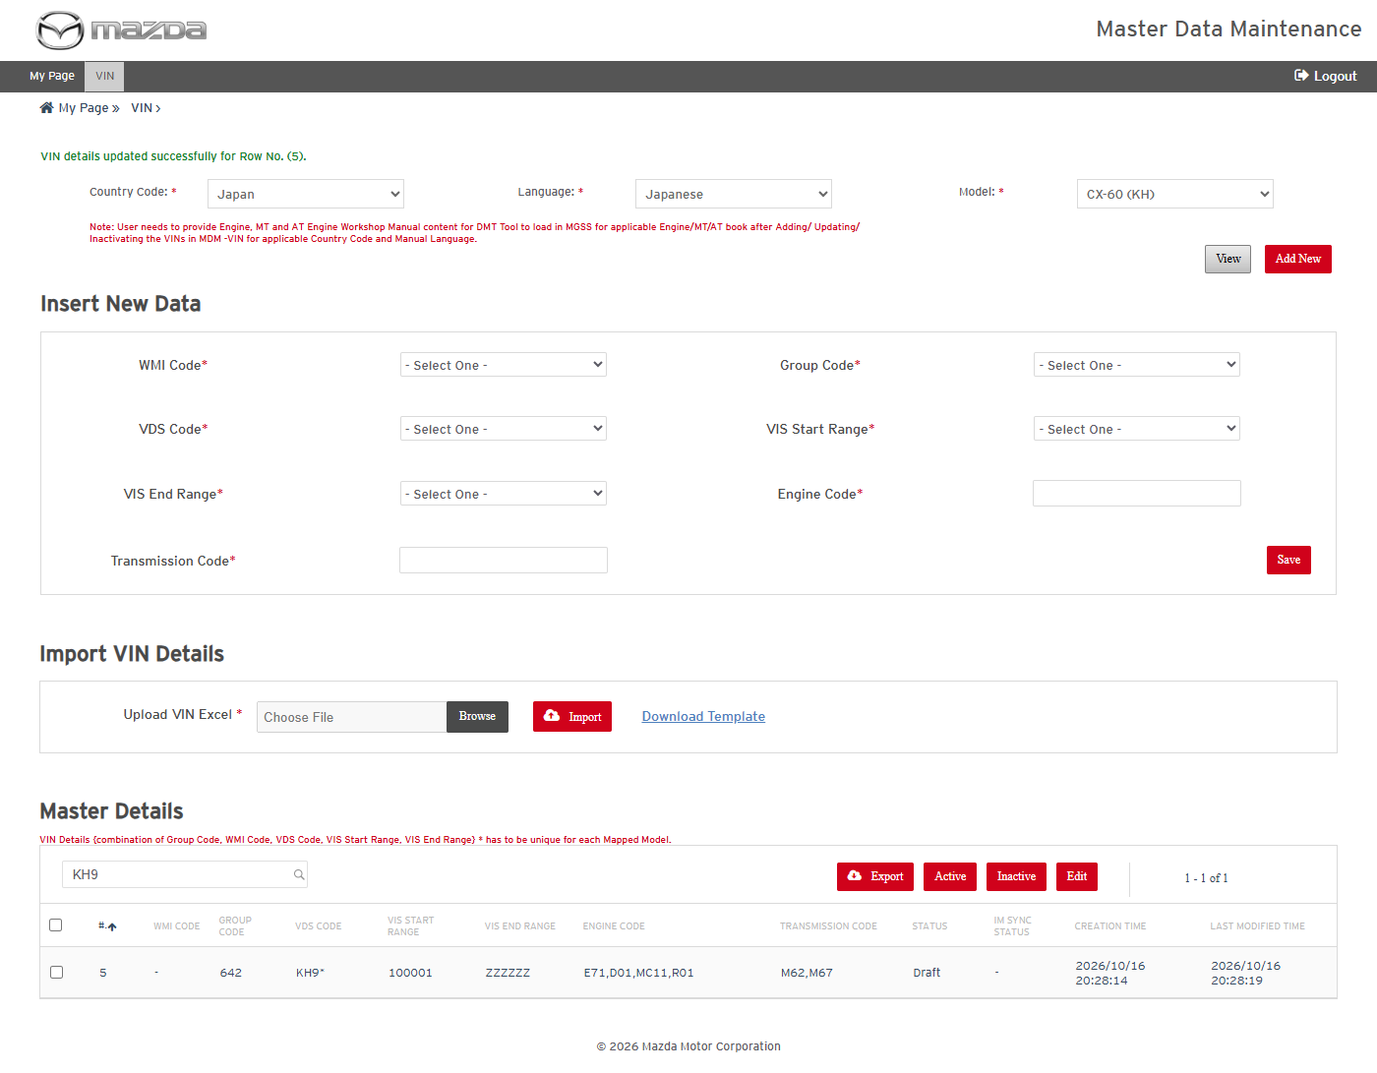
VIN updated
Status: Pass
Remarks:

- User should be able to export the selected VINs.
Steps:
1. Select the KH9* row and click Export.
2. Open the downloaded Excel.
Expected Result: The Excel holds MODEL, CARLINE CODE, GROUP, WMI, VDS, VIS START, VIS END, ENGINE CODE and TRANSMISSION_CODE of the selected VIN.
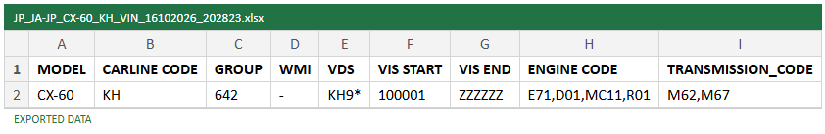
Exported VIN Excel
Status: Pass
Remarks:

- User should be able to add a VIN range by import (Action A).
Steps:
1. Copy the exported row into the VIN template, change VDS to KH8* and set Action A.
2. Choose the Excel in Upload VIN Excel and click Import.
Expected Result: "1 rows successfully imported." is shown and KH8* is listed for the model.
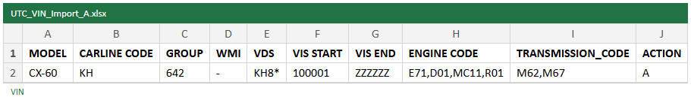
Import file - Action A
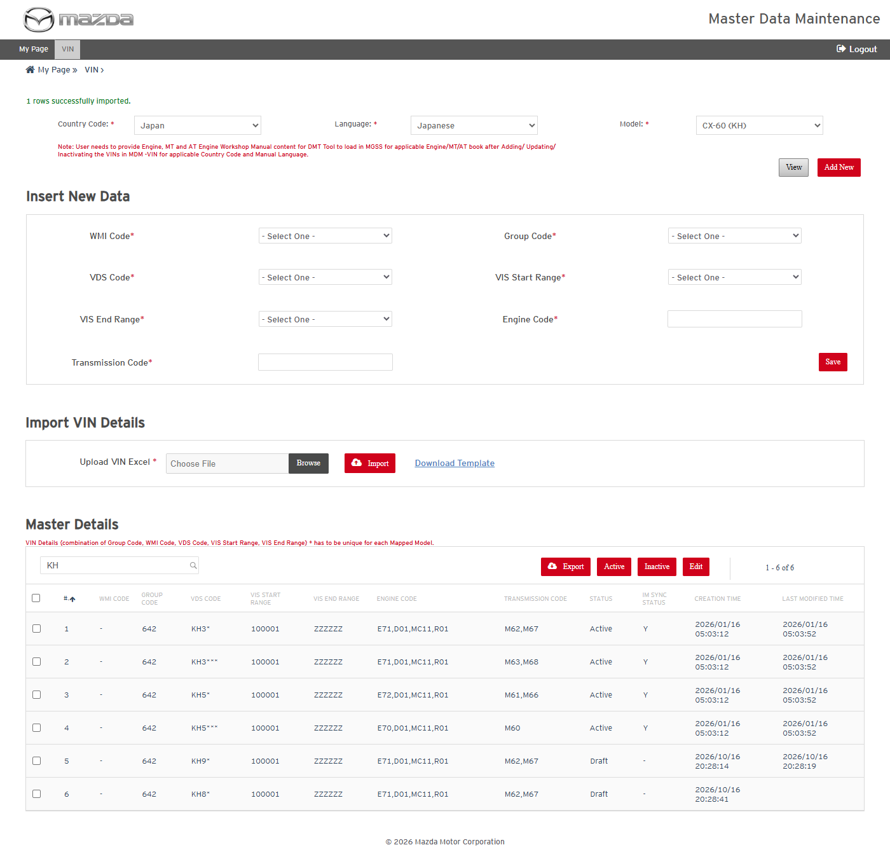
Import result
Status: Pass
Remarks:

- User should be able to delete VIN ranges by import (Action D).
Steps:
1. Import a file with KH9* and KH8* and Action D.
Expected Result: "2 rows successfully deleted." is shown and both VIN ranges are no longer listed.
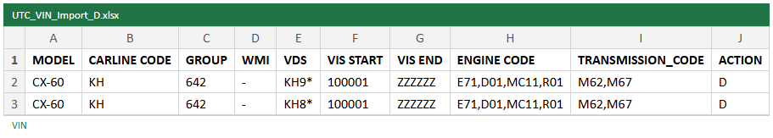
Import file - Action D
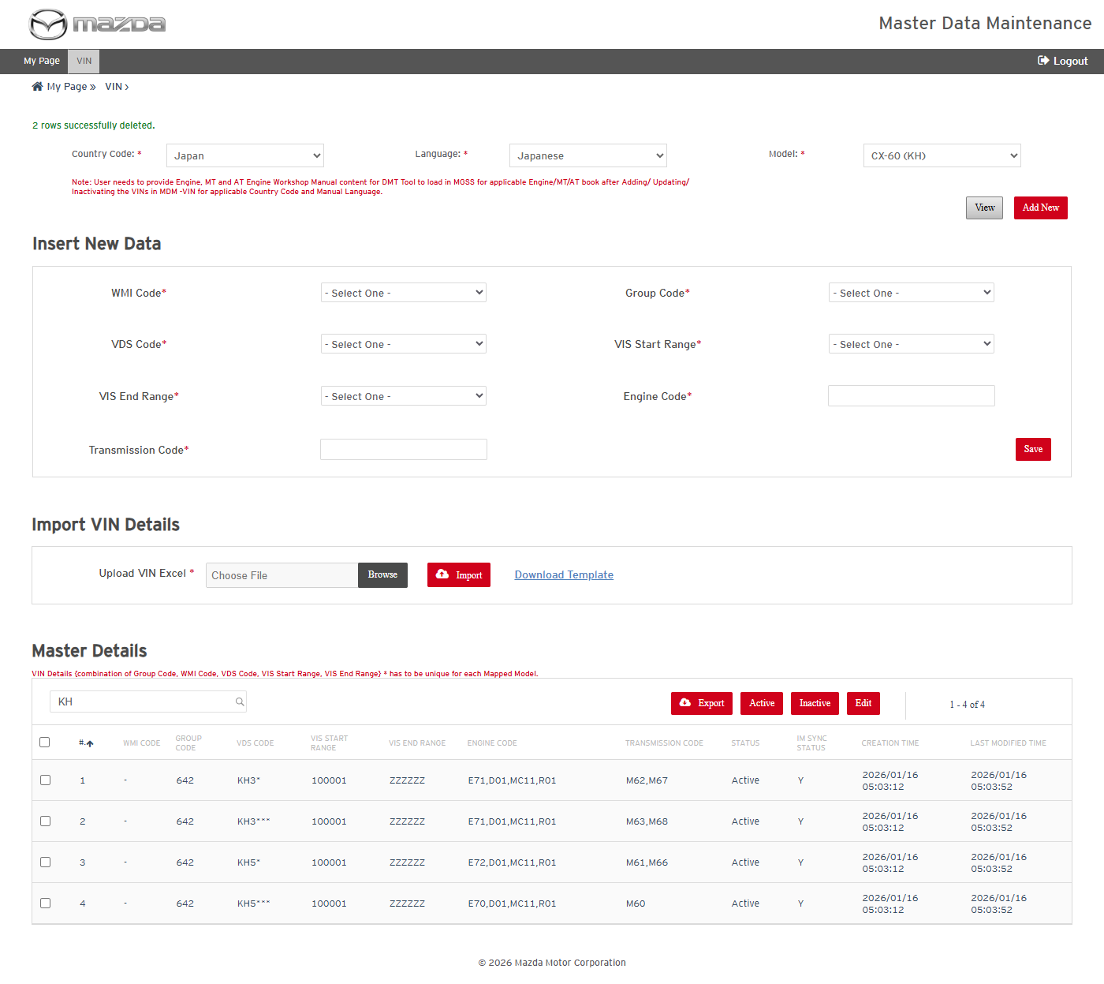
Import result - deleted
Status: Pass
Remarks:

ESI Categories
ESI Categories cases are executed with Country Code Japan / Language Japanese.
- User should be able to view and search ESI Categories.
Steps:
1. Open ESI Categories, select Country Code Japan / Language Japanese and click View.
2. Select Category Level 1 01 (Engine), Level 2 011000 and click Search.
Expected Result: The Level 3 categories under the selected Level 1 / Level 2 are listed with paging.
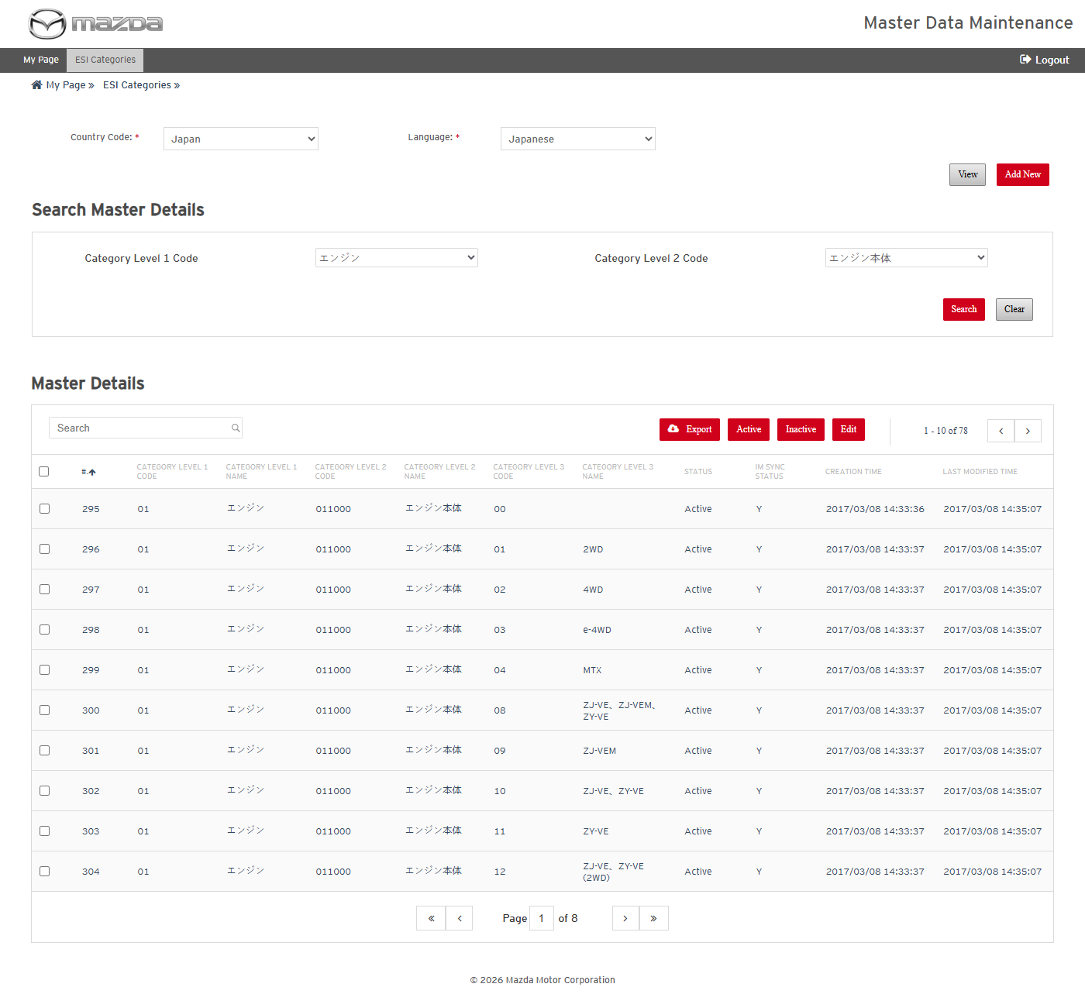
ESI Categories search result
Status: Pass
Remarks:

- User should be able to add a Level 3 ESI Category.
Steps:
1. Click Add New; select Level 1 01 and Level 2 011000.
2. Enter Level 3 Code U9 and Name UTC TEST CATEGORY; click Save.
Expected Result: "Category details saved successfully." is shown and U9 is listed with Status Draft.
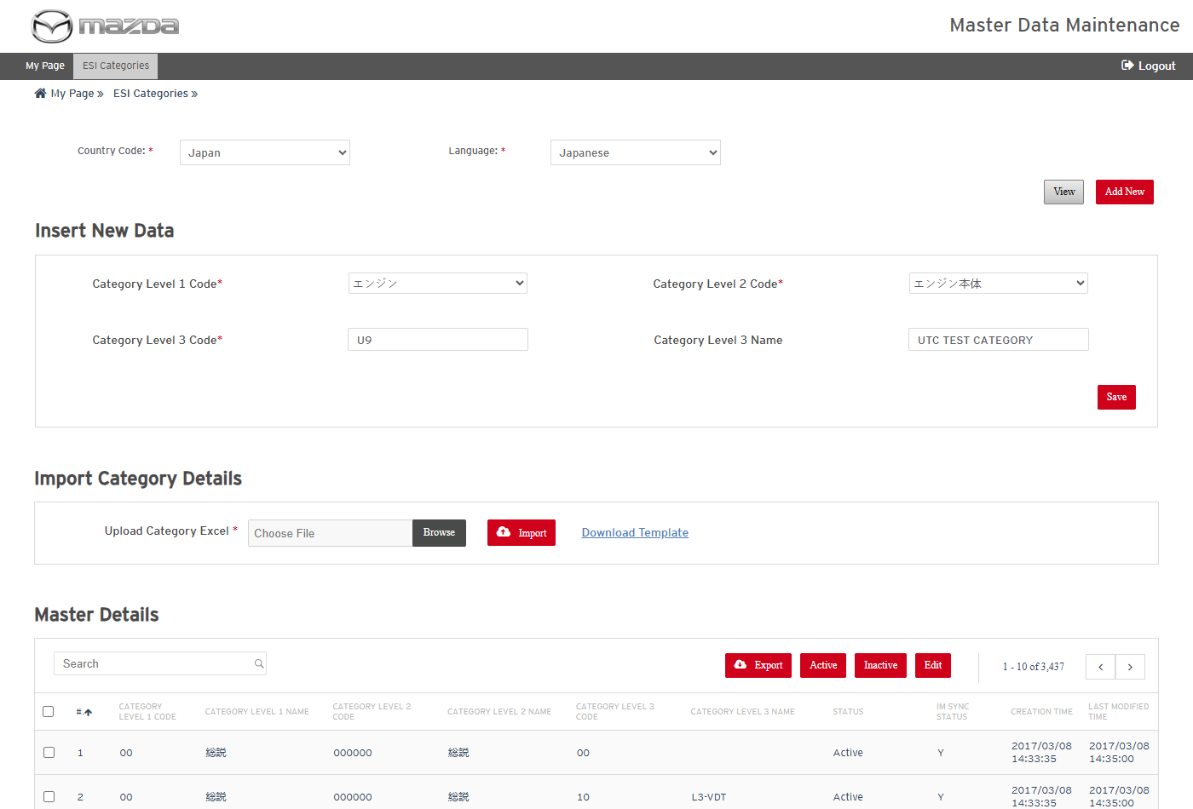
Add New Category form
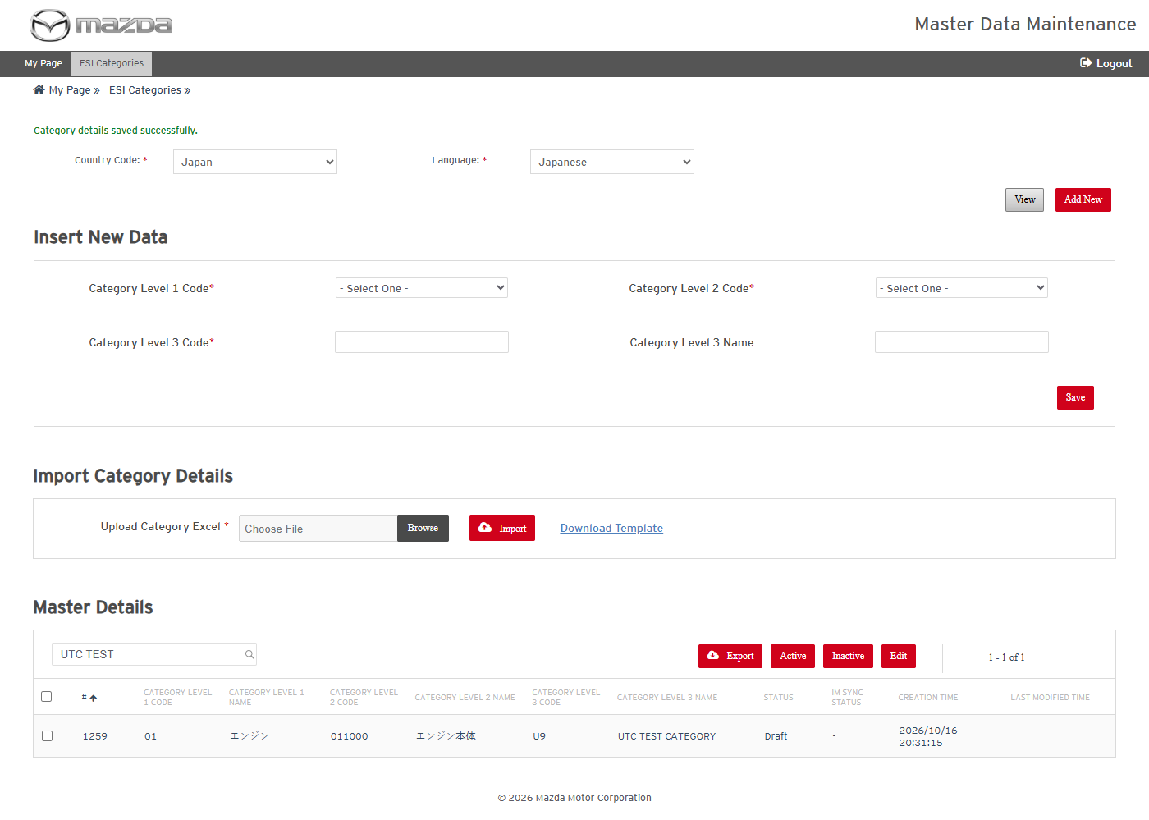
Category saved
Status: Pass
Remarks:

- User should be able to edit an ESI Category.
Steps:
1. Select the U9 row, click Edit, change the Level 3 name and click Save.
Expected Result: "Category details updated successfully for Row No. (n)." is shown and the new name is listed.
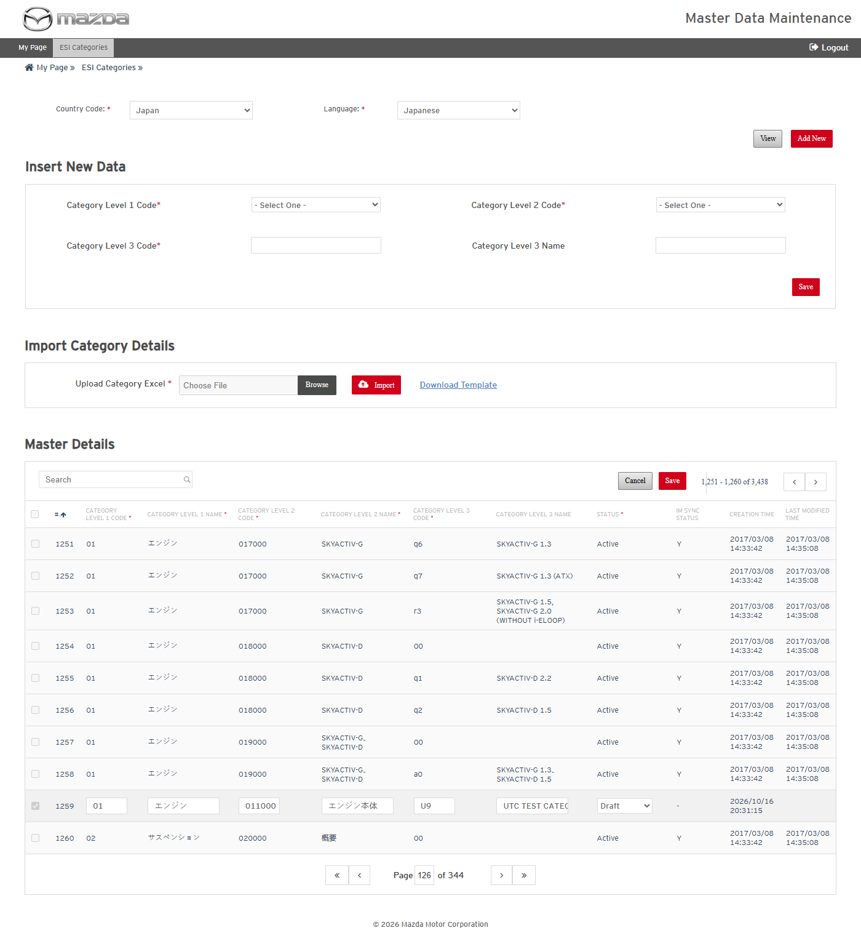
Row in edit mode
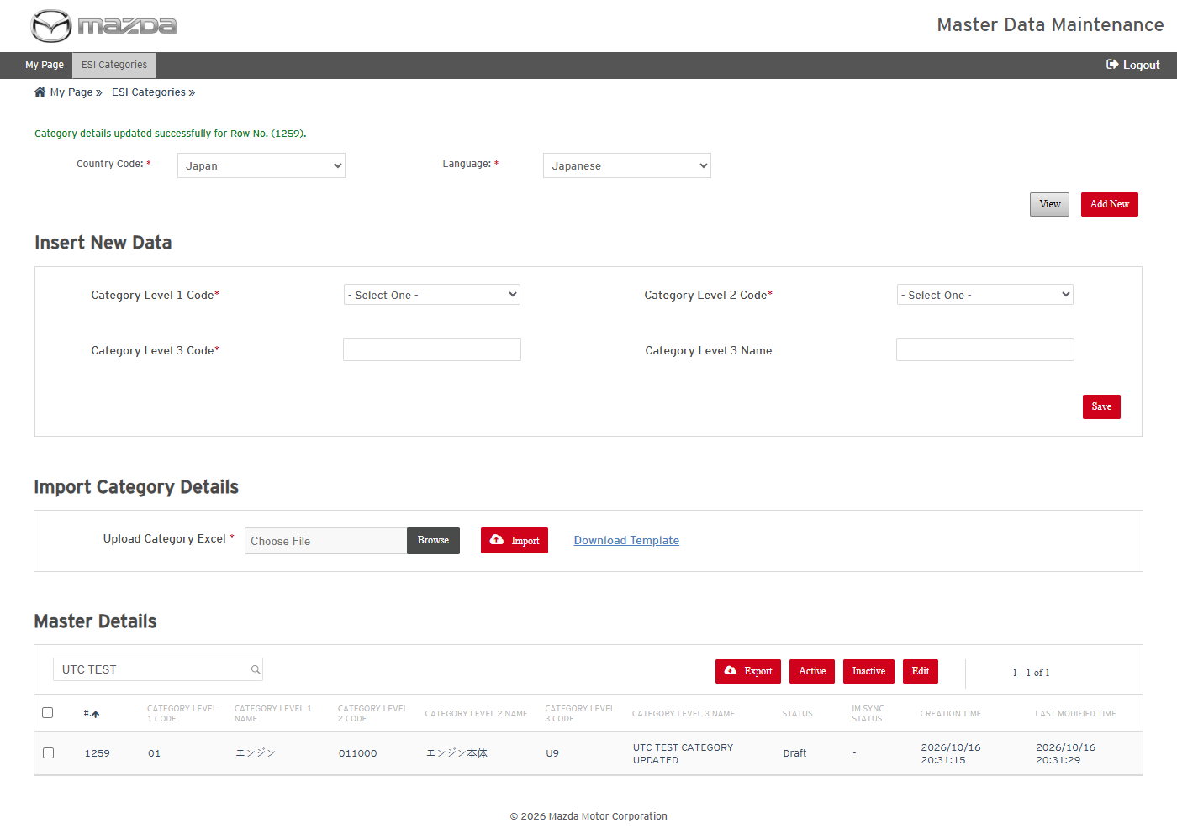
Category updated
Status: Pass
Remarks:

- User should be able to export ESI Categories and delete one by import (Action D).
Steps:
1. Select the U9 row and click Export.
2. Copy the exported row into the template with Action D and Import it.
Expected Result:
- The exported Excel holds the Level 1 / 2 / 3 codes and names of the selected category.
- "1 rows successfully deleted." is shown and U9 is no longer listed.
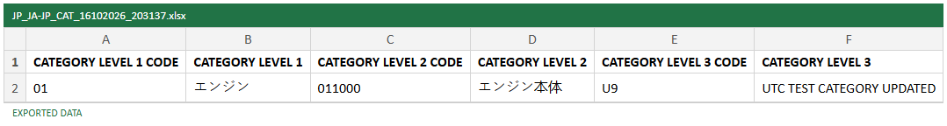
Exported Category Excel
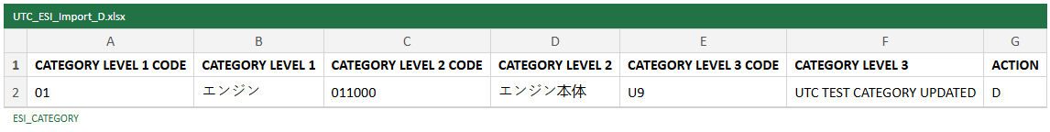
Import file - Action D
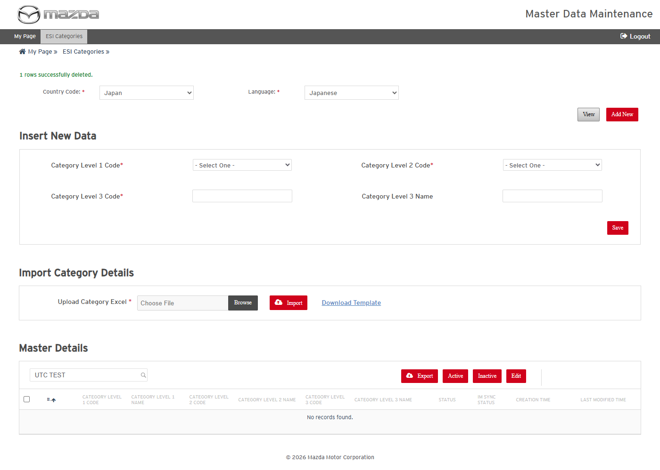
Import result - deleted
Status: Pass
Remarks:

Other Master Data Screens
The remaining Master Data screens share the operations proven above on Carline, VIN and ESI Categories (View, Add, Edit, Active / Inactive, Export, Download Template and Import with the ACTION column). Each screen is covered by adding one record and deleting it again by import.

7.1 Manual Type
- User should be able to add Manual Type data and delete it by import.
Steps:
1. From My Page > Master Data, open Manual Type and select Country Code Japan / Language Japanese.
2. Enter Code UTC, Name UTC TEST MANUAL TYPE and Ref Key UTC_TEST_MANUAL in Insert New Data and click Save.
3. Click Download Template, enter the same record with Action D and save the Excel.
4. Choose the Excel in Upload Excel and click Import.
Expected Result:
- "Manual Type details saved successfully." is shown and the new record is listed with Status Draft.
- "1 rows successfully deleted." is shown and the record is no longer listed.
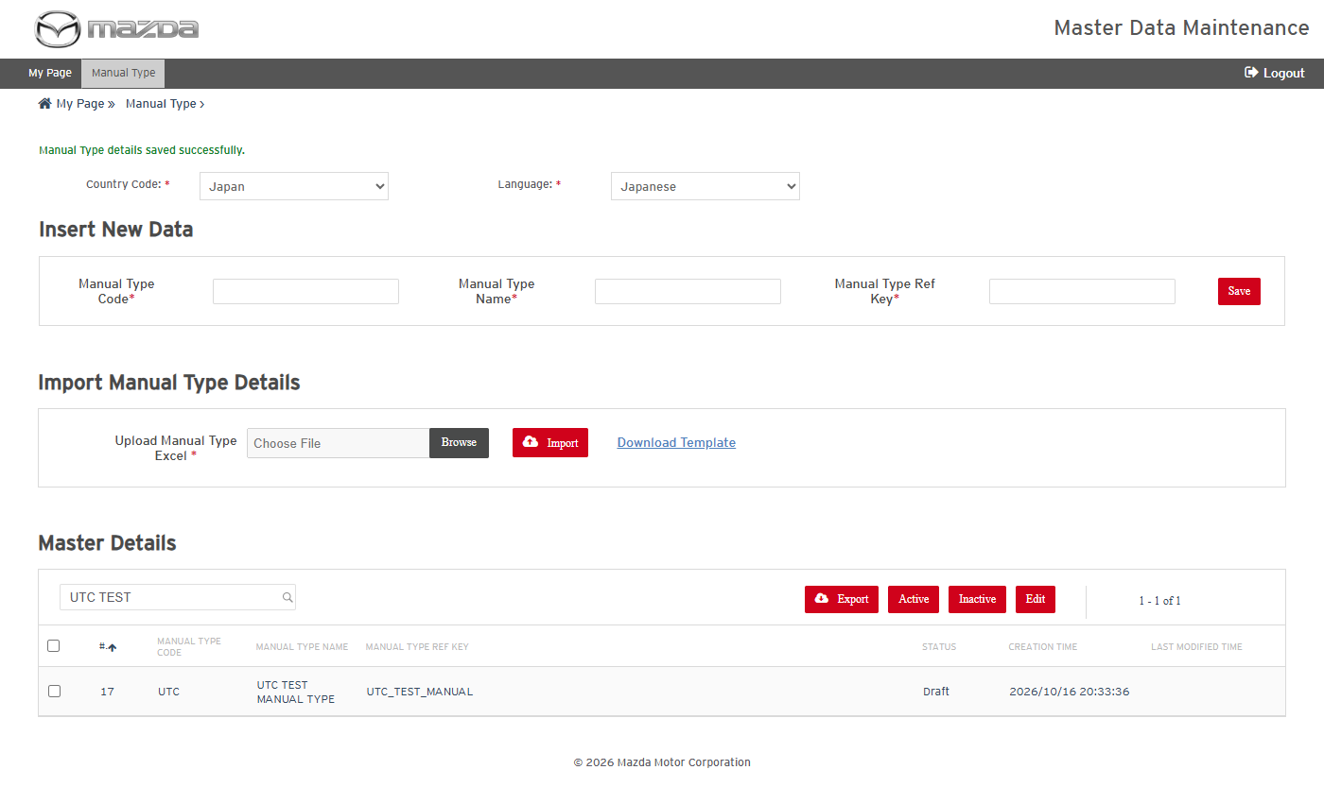
Manual Type - record saved
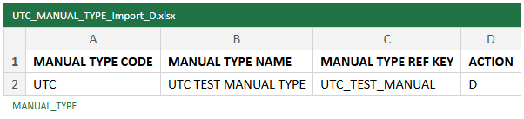
Import file - Action D
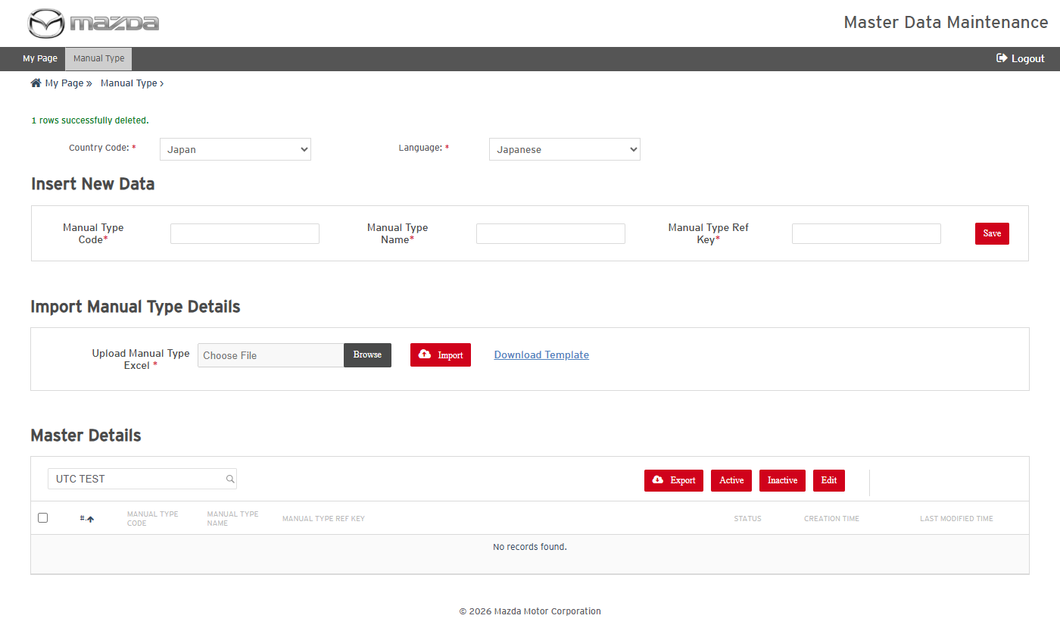
Import result - record deleted
Status: Pass
Remarks:

7.2 Engine Book
- User should be able to add Engine Book data and delete it by import.
Steps:
1. From My Page > Master Data, open Engine > Engine Book and select Country Code Japan / Language Japanese.
2. Enter Engine Book Code UTCEB and the names in Insert New Data and click Save.
3. Click Download Template, enter the same record with Action D and save the Excel.
4. Choose the Excel in Upload Excel and click Import.
Expected Result:
- "Engine Book details saved successfully." is shown and the new record is listed with Status Draft.
- "1 rows successfully deleted." is shown and the record is no longer listed.
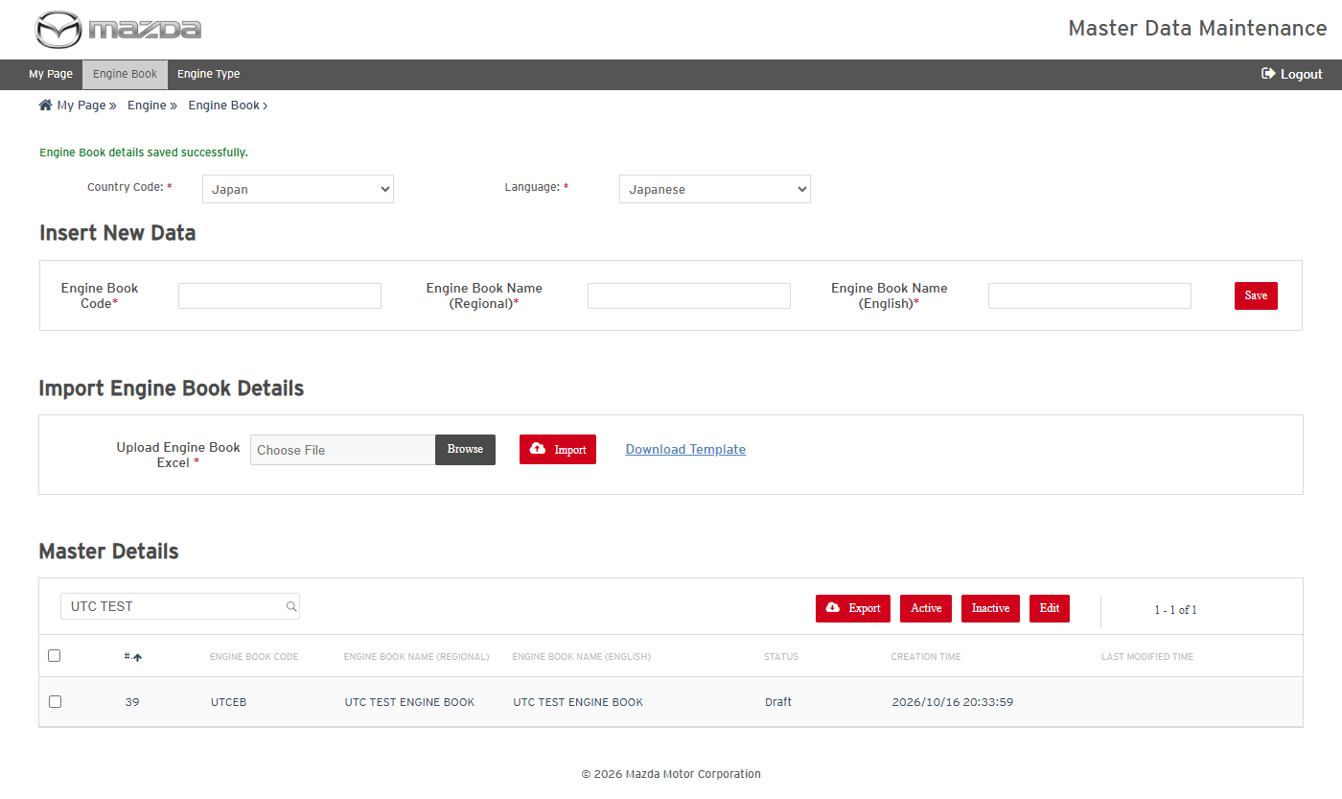
Engine Book - record saved
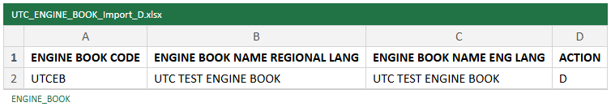
Import file - Action D
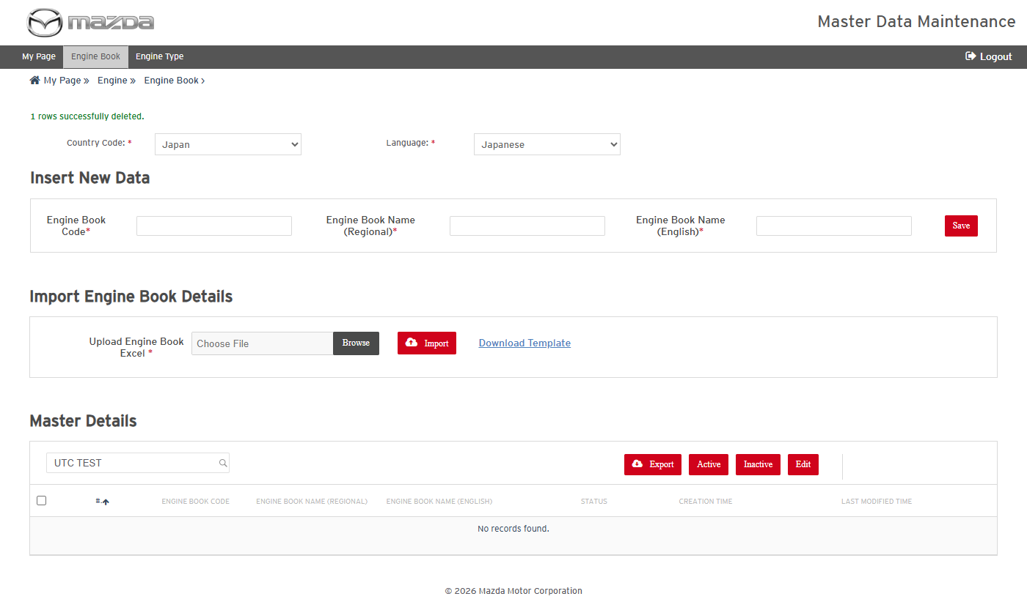
Import result - record deleted
Status: Pass
Remarks:

7.3 Engine Type
- User should be able to add Engine Type data and delete it by import.
Steps:
1. From My Page > Master Data, open Engine > Engine Type and select Country Code Japan / Language Japanese and an Engine Book.
2. Enter Engine Type Code UTCET, Name UTC TEST ENGINE TYPE and Group Type in Insert New Data and click Save.
3. Click Download Template, enter the same record with Action D and save the Excel.
4. Choose the Excel in Upload Excel and click Import.
Expected Result:
- "Engine Type details saved successfully." is shown and the new record is listed with Status Draft.
- "1 rows successfully deleted." is shown and the record is no longer listed.
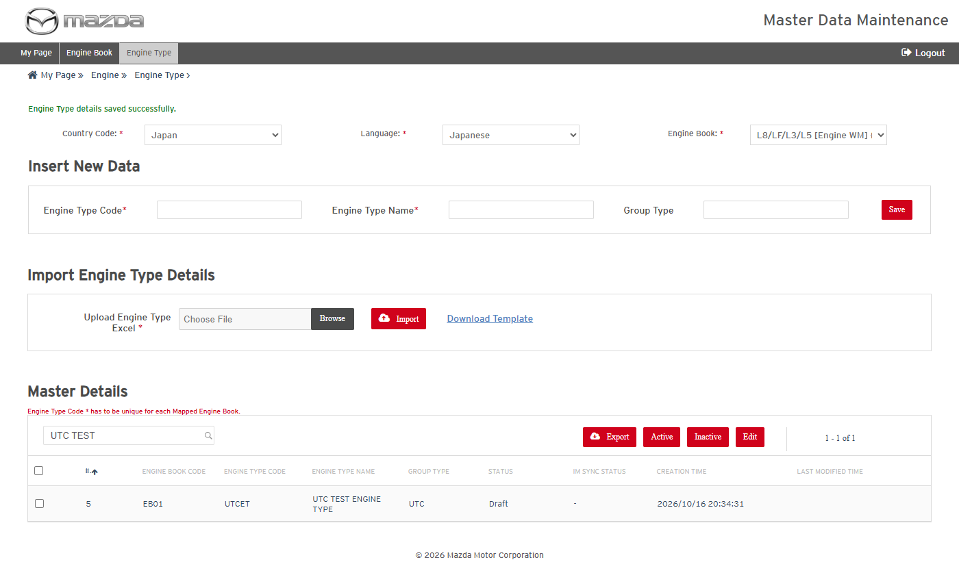
Engine Type - record saved
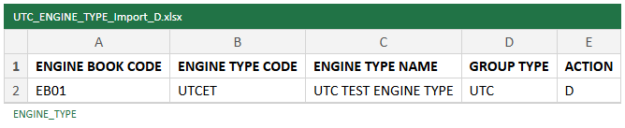
Import file - Action D
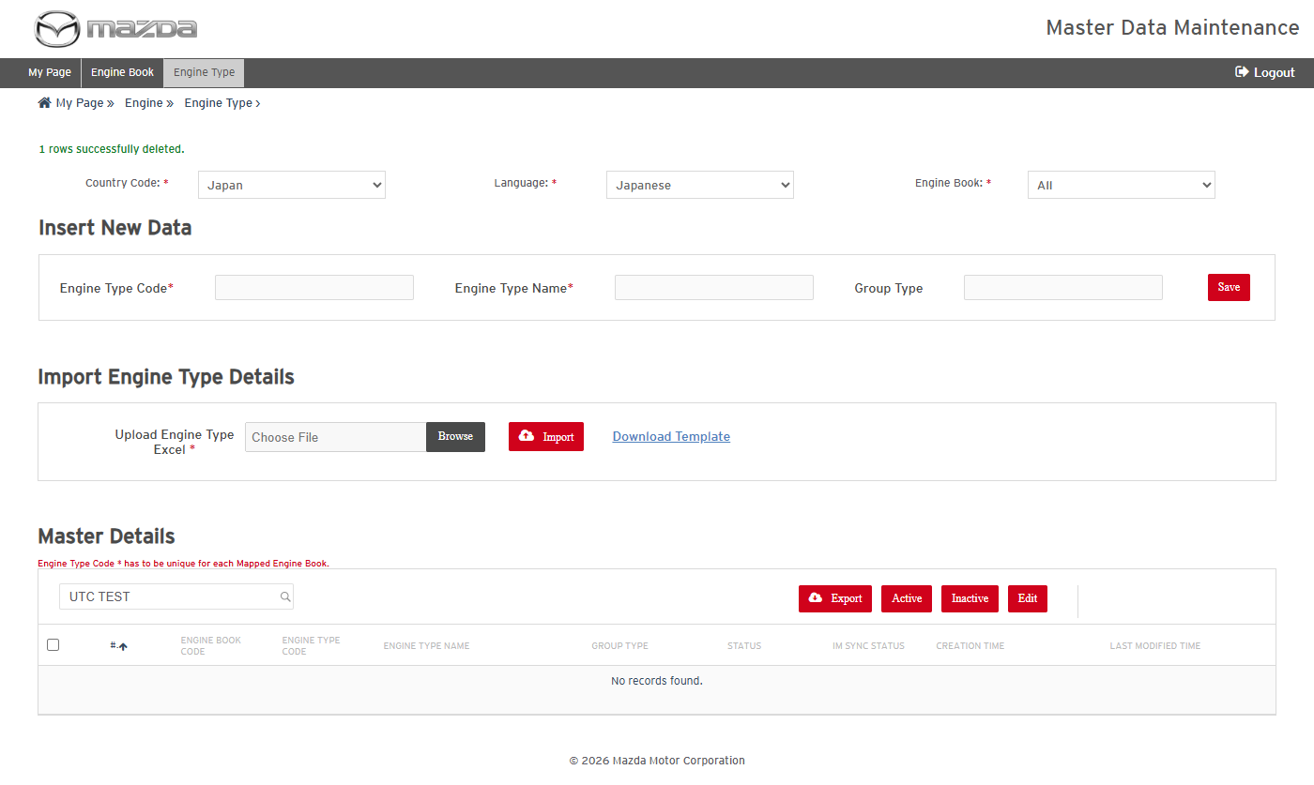
Import result - record deleted
Status: Pass
Remarks:

7.4 Transmission Book
- User should be able to add Transmission Book data and delete it by import.
Steps:
1. From My Page > Master Data, open Transmission > Transmission Book and select Country Code Japan / Language Japanese.
2. Enter Transmission Book Code UTCTB and the names in Insert New Data and click Save.
3. Click Download Template, enter the same record with Action D and save the Excel.
4. Choose the Excel in Upload Excel and click Import.
Expected Result:
- "Transmission Book details saved successfully." is shown and the new record is listed with Status Draft.
- "1 rows successfully deleted." is shown and the record is no longer listed.
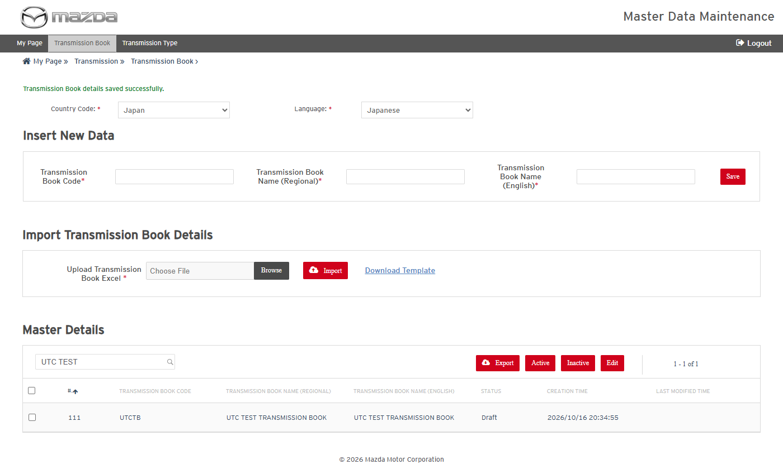
Transmission Book - record saved
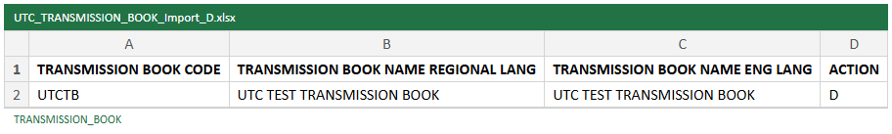
Import file - Action D
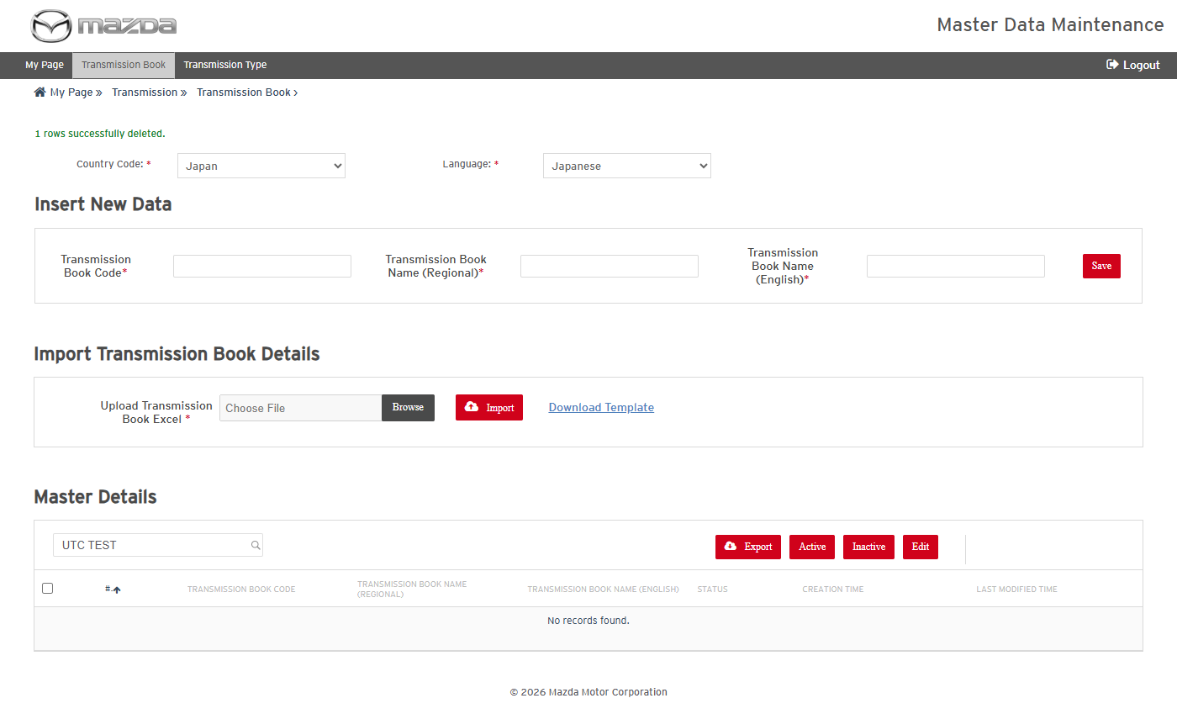
Import result - record deleted
Status: Pass
Remarks:

7.5 Transmission Type
- User should be able to add Transmission Type data and delete it by import.
Steps:
1. From My Page > Master Data, open Transmission > Transmission Type and select Country Code Japan / Language Japanese and a Transmission Book.
2. Enter Transmission Type Code UTCTT and Name in Insert New Data and click Save.
3. Click Download Template, enter the same record with Action D and save the Excel.
4. Choose the Excel in Upload Excel and click Import.
Expected Result:
- "Transmission Type details saved successfully." is shown and the new record is listed with Status Draft.
- "1 rows successfully deleted." is shown and the record is no longer listed.
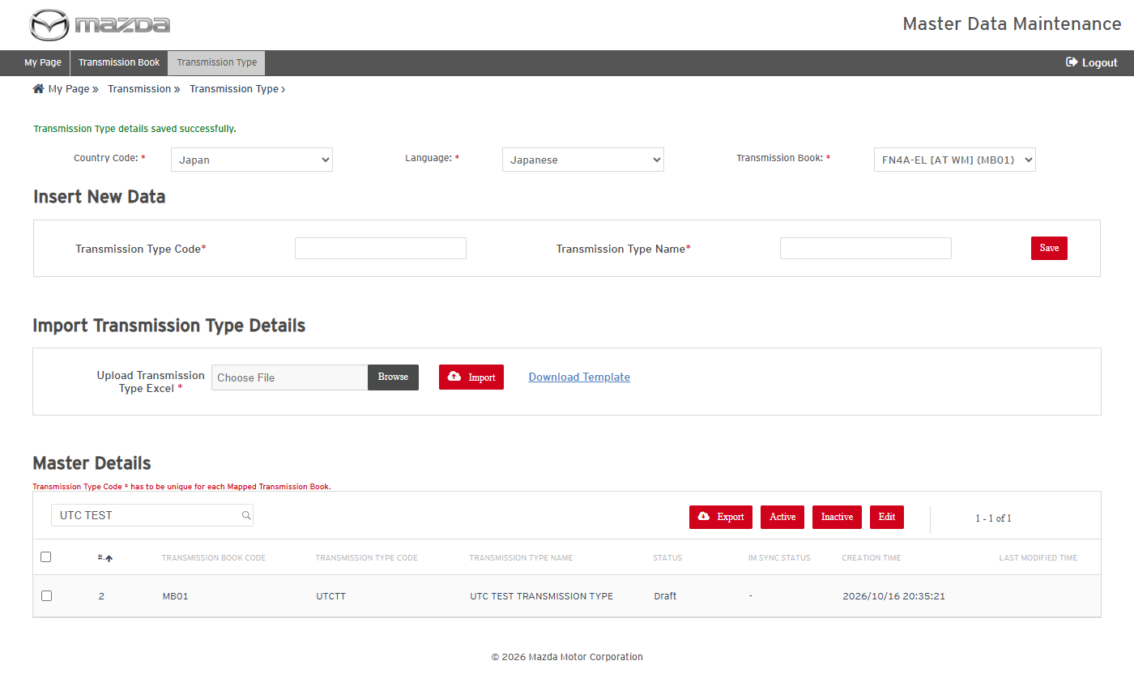
Transmission Type - record saved
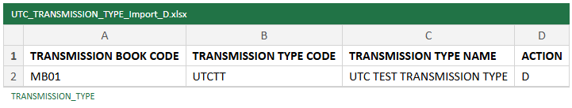
Import file - Action D
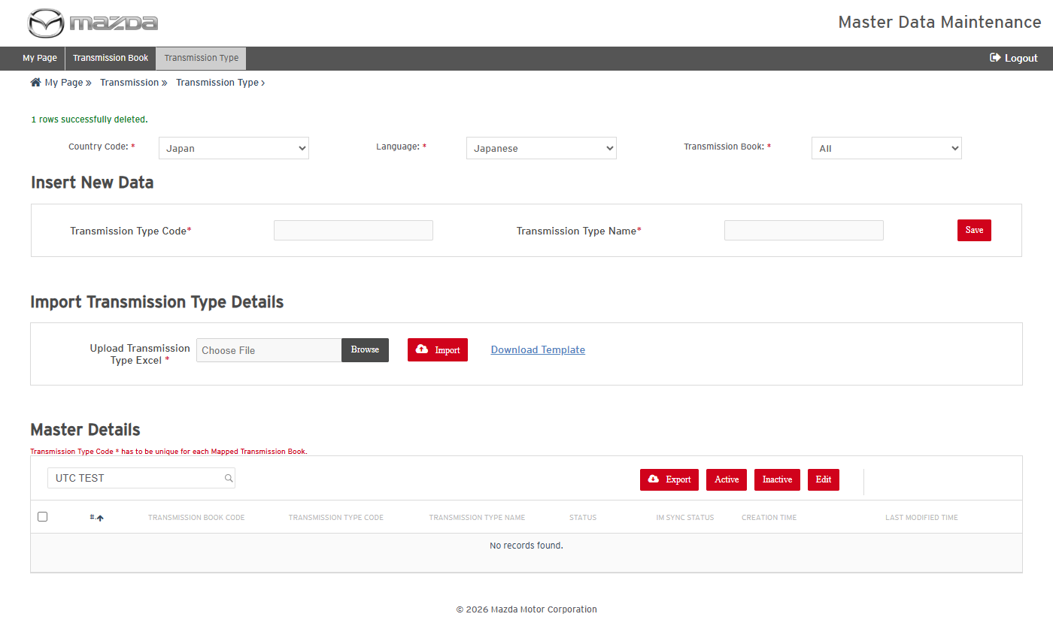
Import result - record deleted
Status: Pass
Remarks:

7.6 Drive Axle Type
- User should be able to add Drive Axle Type data and delete it by import.
Steps:
1. From My Page > Master Data, open Vehicle Type > Drive Axle Type and select Country Code Japan / Language Japanese.
2. Enter Drive Axle Type Code UTCAX and the descriptions in Insert New Data and click Save.
3. Click Download Template, enter the same record with Action D and save the Excel.
4. Choose the Excel in Upload Excel and click Import.
Expected Result:
- "Drive Axle Type details saved successfully." is shown and the new record is listed with Status Draft.
- "1 rows successfully deleted." is shown and the record is no longer listed.
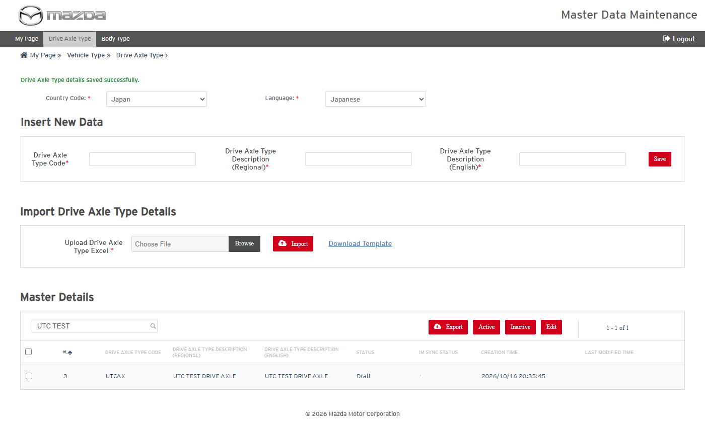
Drive Axle Type - record saved
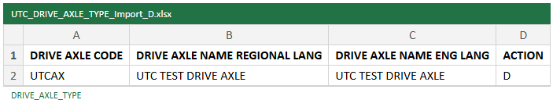
Import file - Action D
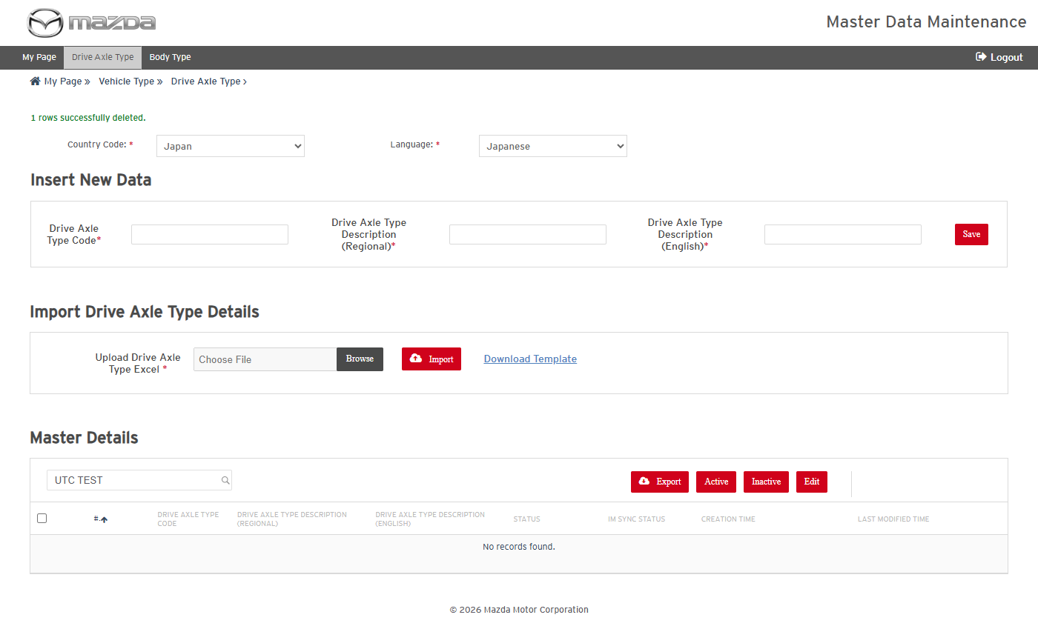
Import result - record deleted
Status: Pass
Remarks:

7.7 Body Type
- User should be able to add Body Type data and delete it by import.
Steps:
1. From My Page > Master Data, open Vehicle Type > Body Type and select Country Code Japan / Language Japanese.
2. Enter Body Type Code UTCBD and the descriptions in Insert New Data and click Save.
3. Click Download Template, enter the same record with Action D and save the Excel.
4. Choose the Excel in Upload Excel and click Import.
Expected Result:
- "Body Type details saved successfully." is shown and the new record is listed with Status Draft.
- "1 rows successfully deleted." is shown and the record is no longer listed.
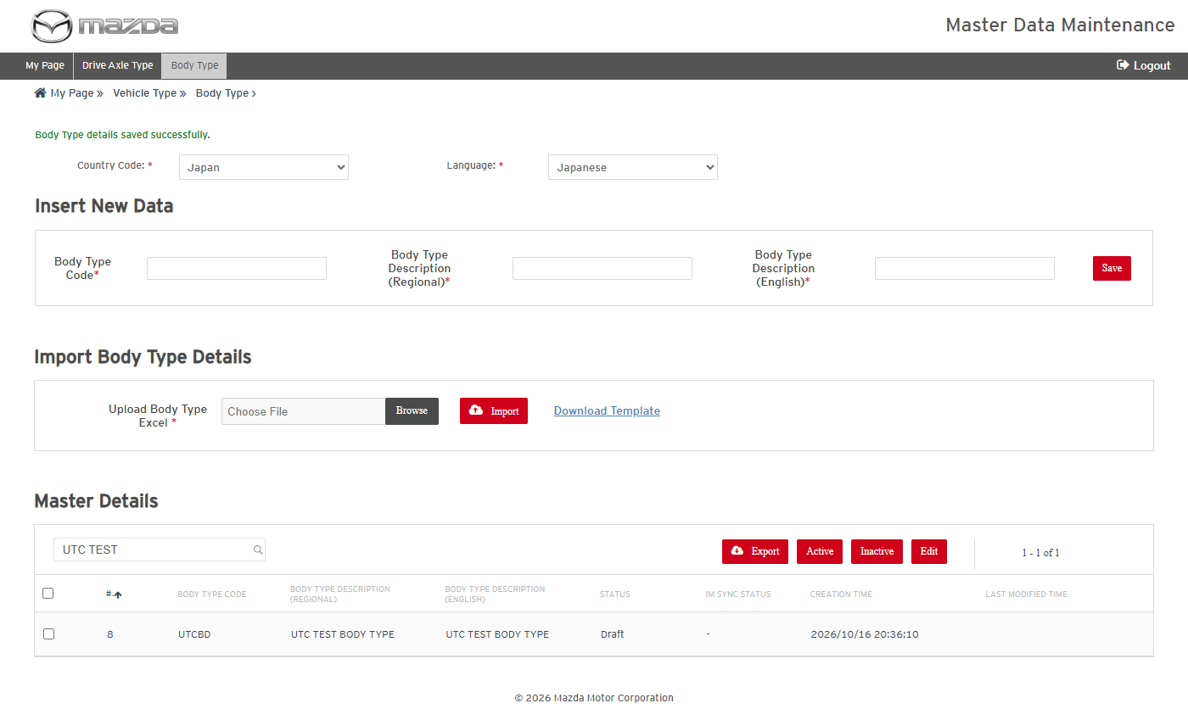
Body Type - record saved
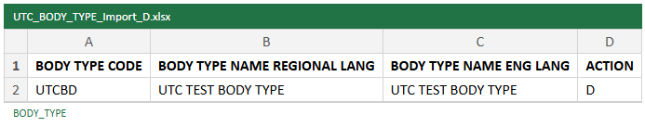
Import file - Action D
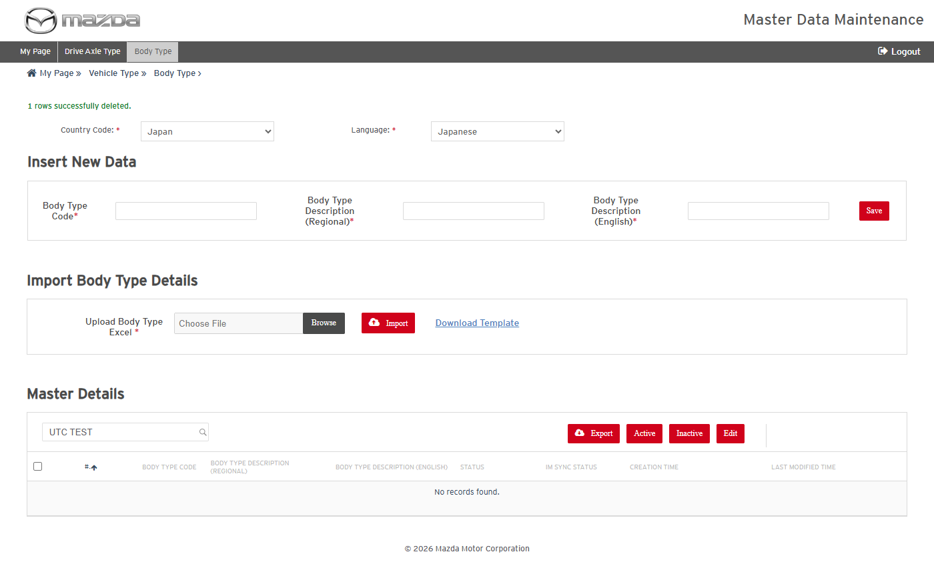
Import result - record deleted
Status: Pass
Remarks:

7.8 MNAO Model Year Code Mapping
- User should be able to add MNAO Model Year Code Mapping data and delete it by import.
Steps:
1. From My Page > Master Data, open MNAO Model Year Code Mapping and select Country Code United States / Language English Us.
2. Enter Year 2099 and Code U in Insert New Data and click Save.
3. Click Download Template, enter the same record with Action D and save the Excel.
4. Choose the Excel in Upload Excel and click Import.
Expected Result:
- "MNAO Model Year Code Mapping details saved successfully." is shown and the new record is listed with Status Draft.
- "1 rows successfully deleted." is shown and the record is no longer listed.
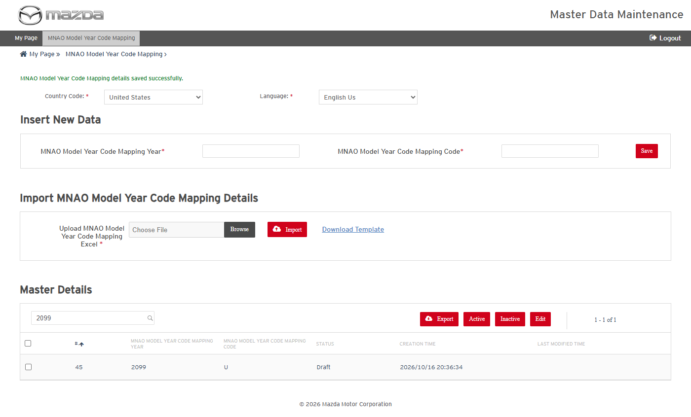
MNAO Model Year Code Mapping - record saved
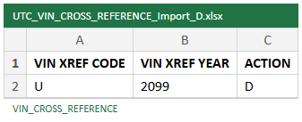
Import file - Action D
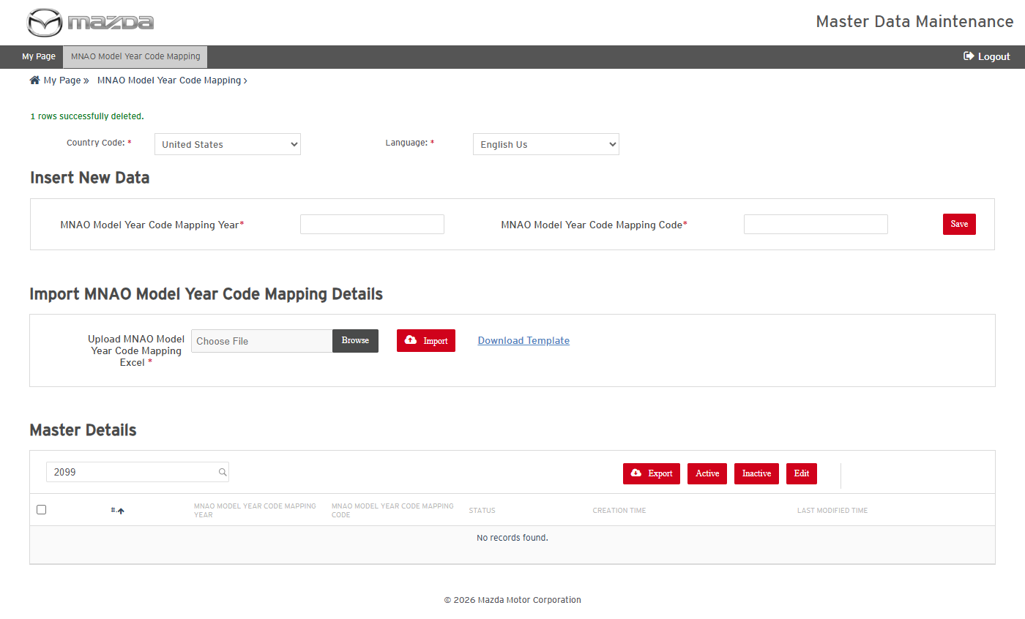
Import result - record deleted
Status: Pass
Remarks:

7.9 Master Data Locale Mapping
- User should be able to add Master Data Locale Mapping data and delete it by import.
Steps:
1. From My Page > Master Data, open Master Data Locale Mapping and select Market MC.
2. Enter Processing Locale zz-JP, Master Data Type Carline + VIN (CARLINE) and Alternate Locale ja-JP in Insert New Data and click Save.
3. Click Download Template, enter the same record with Action D and save the Excel.
4. Choose the Excel in Upload Excel and click Import.
Expected Result:
- "Master Data Locale Mapping details saved successfully." is shown and the new record is listed with Status Active.
- "1 rows successfully deleted." is shown and the record is no longer listed.
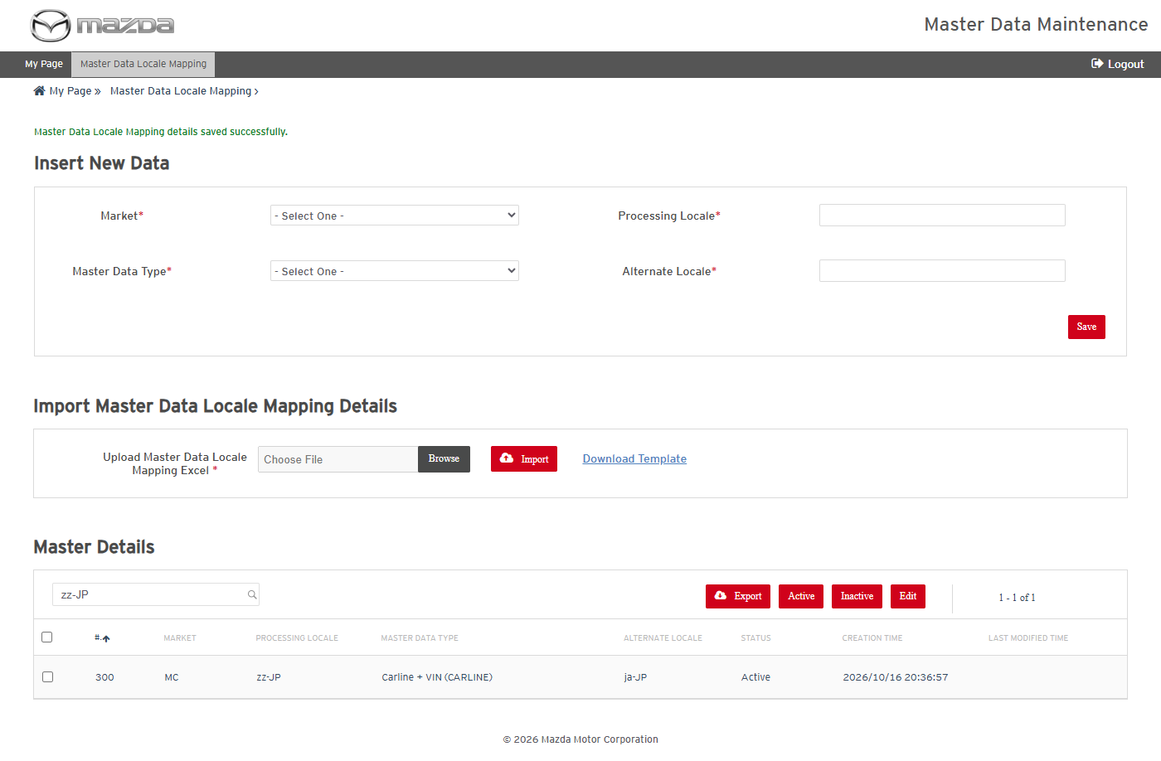
Master Data Locale Mapping - record saved
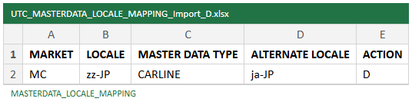
Import file - Action D
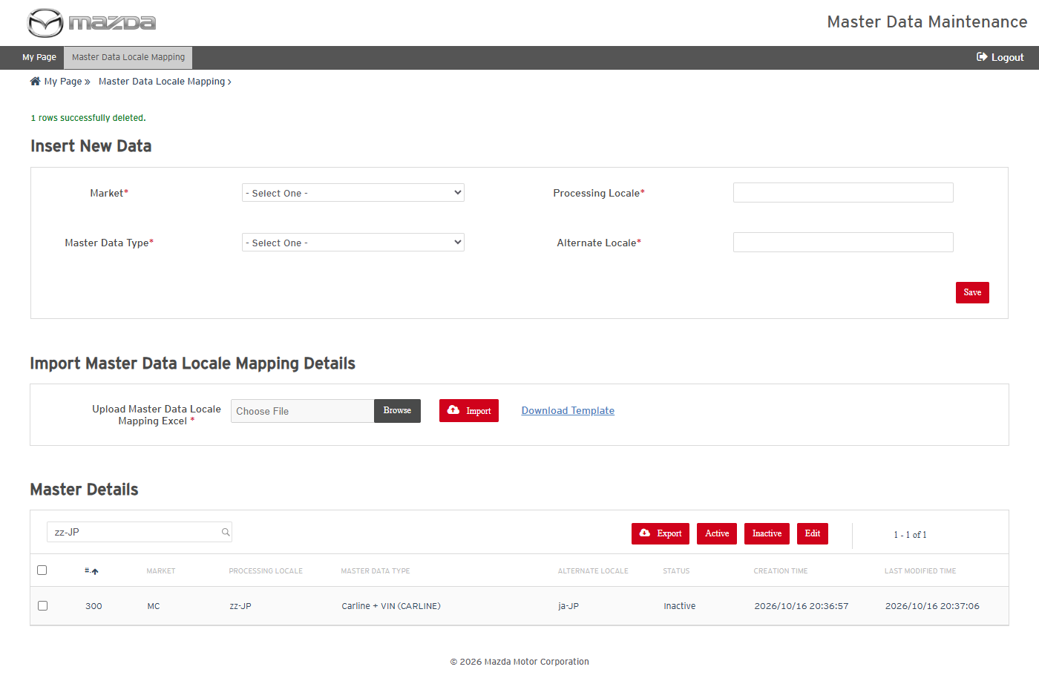
Import result - record deleted
Status: Pass
Remarks:

